Project 1

Deployment the website on AWS EC2 Instance Virtual private cloud

Steps : 1. In AWS console, search VPC.

2. In VPC dashboard , you will get my VPC’s and click on myvpc’s.

3. Click on create VPC. Select resource to create as vpc only.

4. Give name as Likhin-vpc and IPv4 CIDR as 10.0.0.0/16.

5. Then click on create VPC. 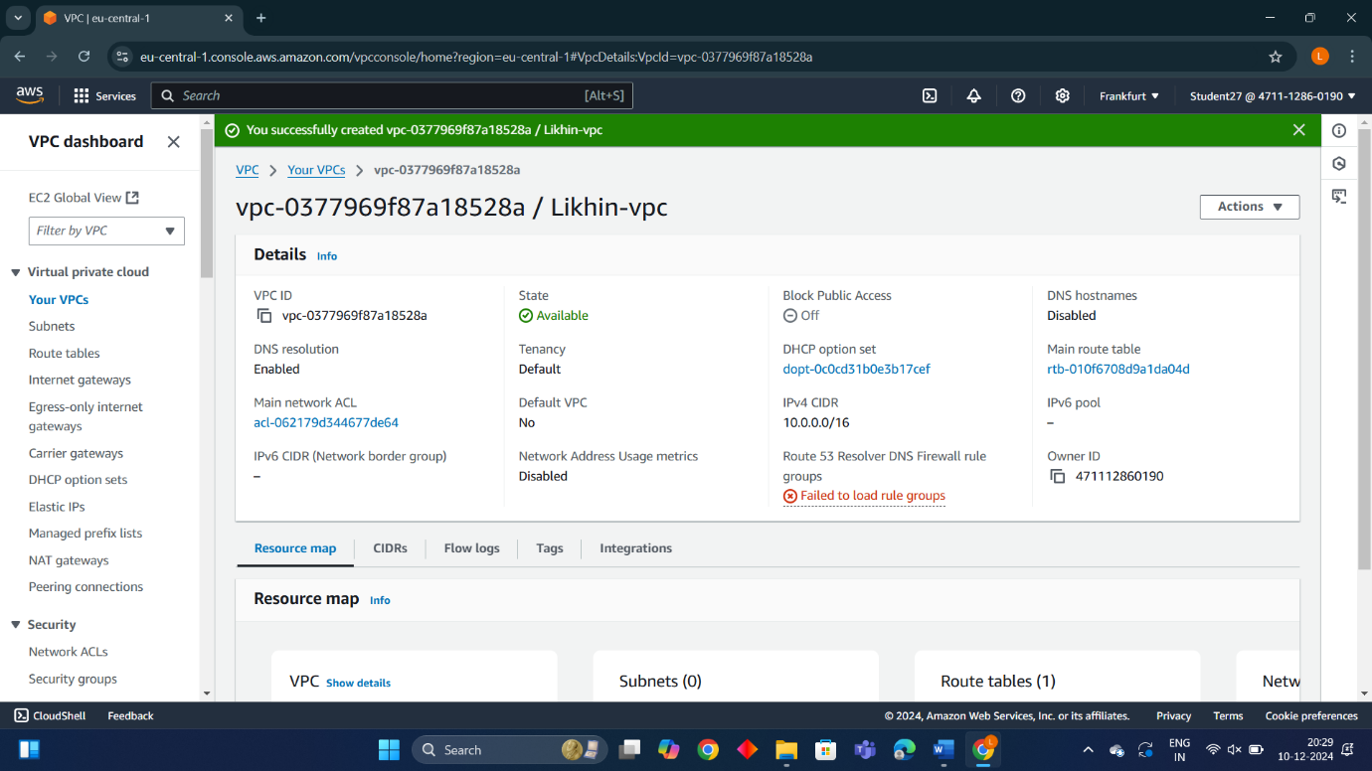

Internet Gateway:

Steps: 1. In VPC dashboard, click on Internet Gateway.

2. To create Internet gateway, click on create Internet Gateway.

3. Then give name as likhin-igw and click on create Internet Gateway.

4. Your internet Gateway is created.

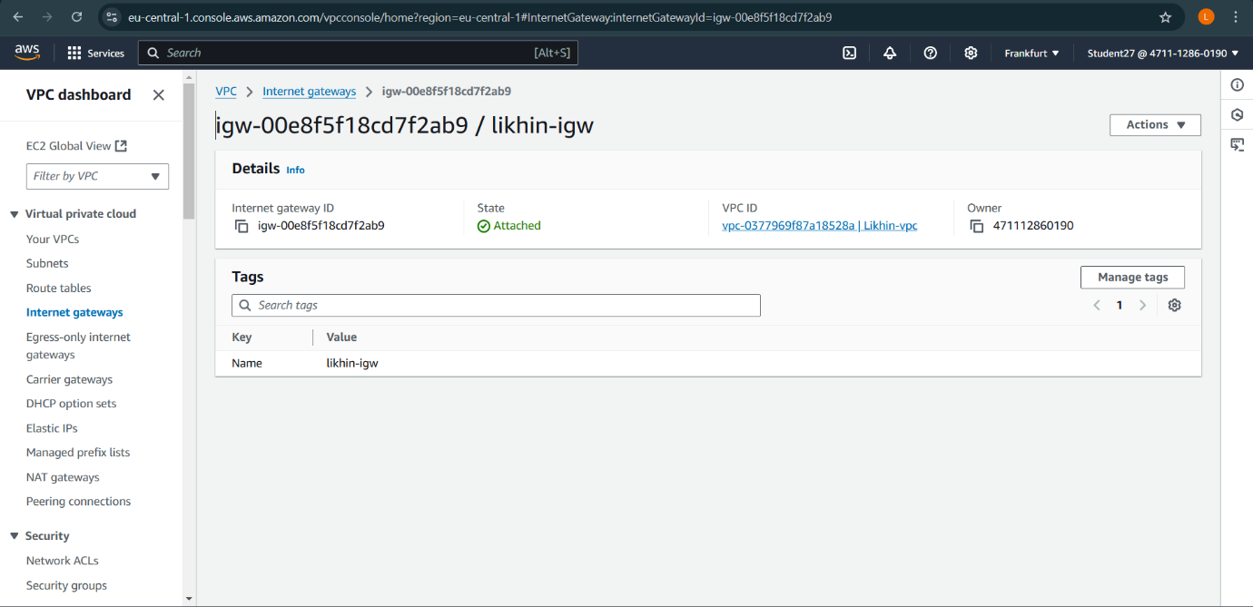

Public Subnet 1:

Steps: 1. To create subnet, go to VPC dashboard under virtual private cloud, click on subnet.

2. Select the vpc you have already created and in subnet setting, give subnet name as likhin-public-sub1 .

3. Then choose availability zone as region you have selected before creating the vpc and IPv4 subnet CIDR block as 10.0.1.0/24.

4. Then create one more subnet as following subnet but give name as likhin-public sub2 and then choose availability zone and IPv4 subnet CIDR block as 10.0.2.0/24. 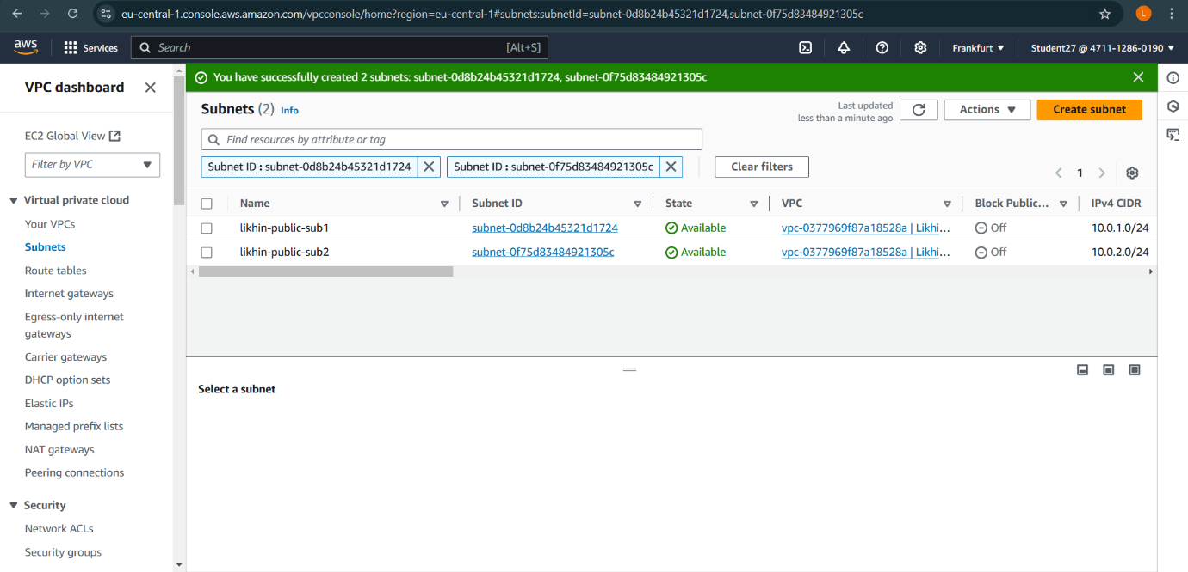

Router Table:

Steps: 1. To create Route table, click on create route table.

2. In route table setting, give route table name as likhin-RT and select vpc that is created. 3. Then click on create route table.

4. After route table is created, go to routes and click on edit route and then click on add route.

5. Then in destination, select 0.0.0.0/0 as destination and target as Internet Gateways .

6. After selecting internet gateway, it allows to select the igw- and select the internet gateway that is created by you.

7. At last click on save changes.

8. Then go to subnet association and click on edit subnet association.

9. Select the subnet you have created and click on save changes.

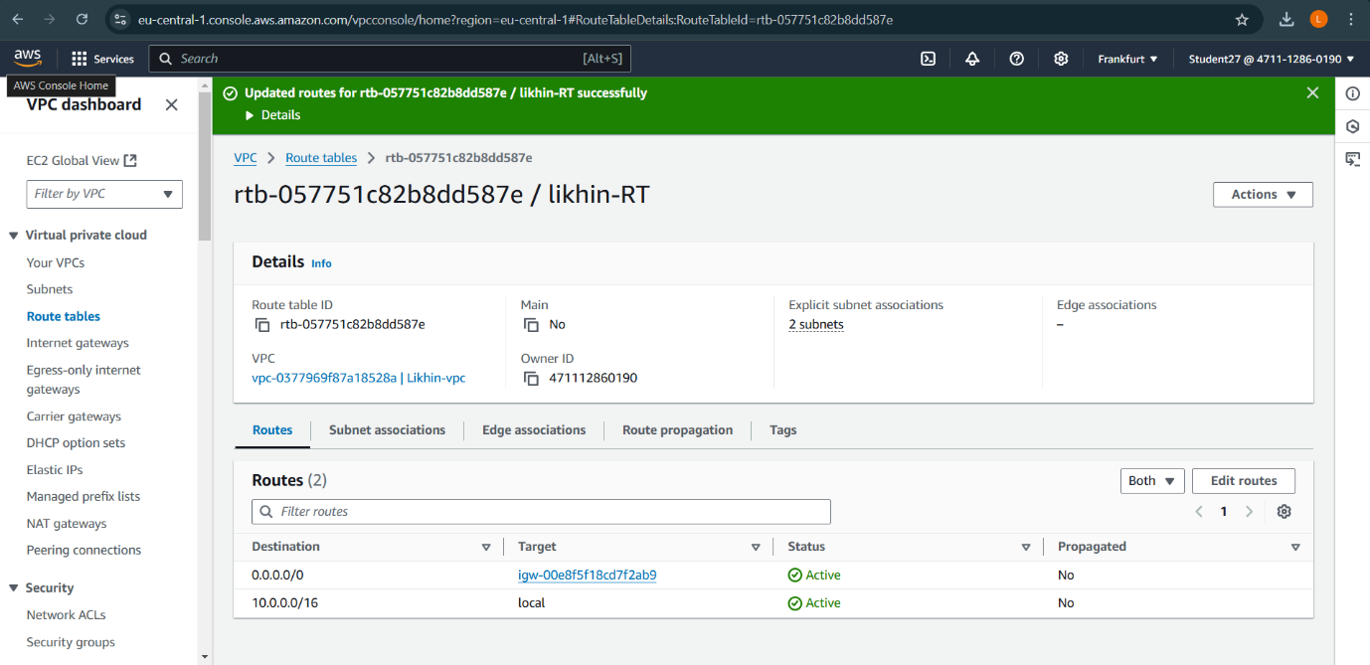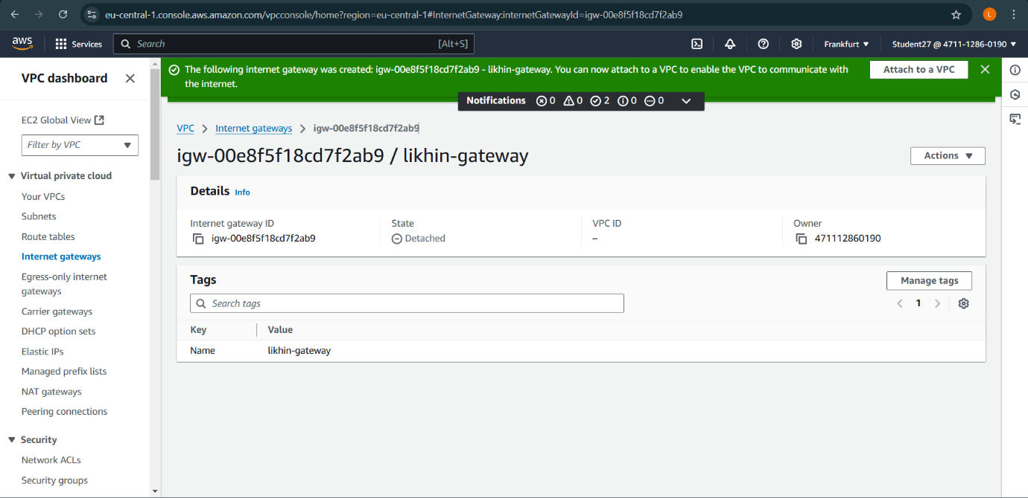

EC2 Instance:

Steps: 1. Go to EC2 in AWS console and click on instances.

2. Click on launch instance and give the name for the instances as LIKHIN-server.

3. After giving name to instances, select application and OS Images as Amazon Linux and instances type as t2.micro .

4. In keypair, click on create keypair and give keypair name as likhin-public-keypair and click on create keypair. The keypair is created.

5. Then in network setting, click edit. Select vpc and subnet and also assign public IP as enable. 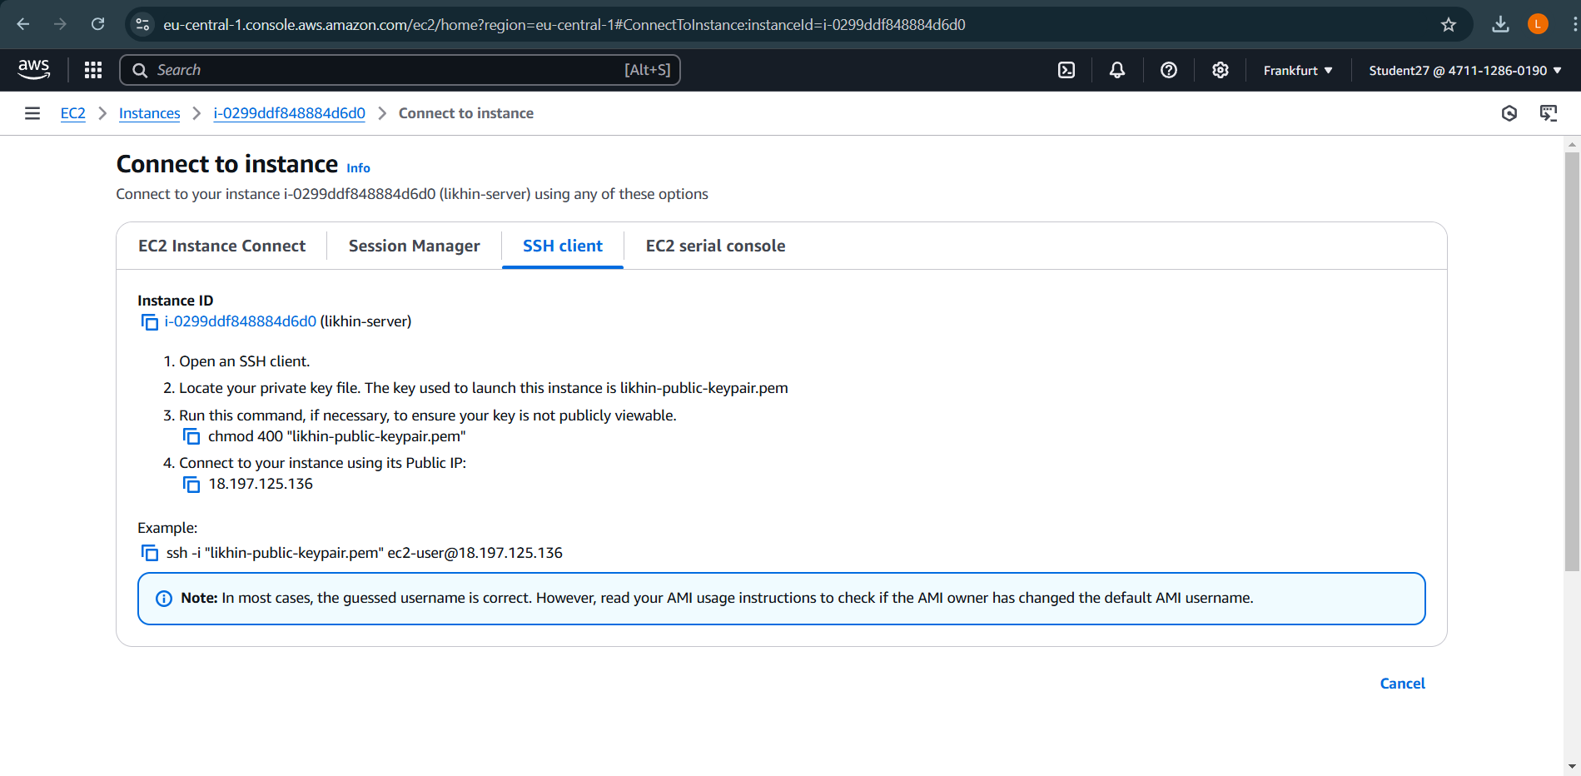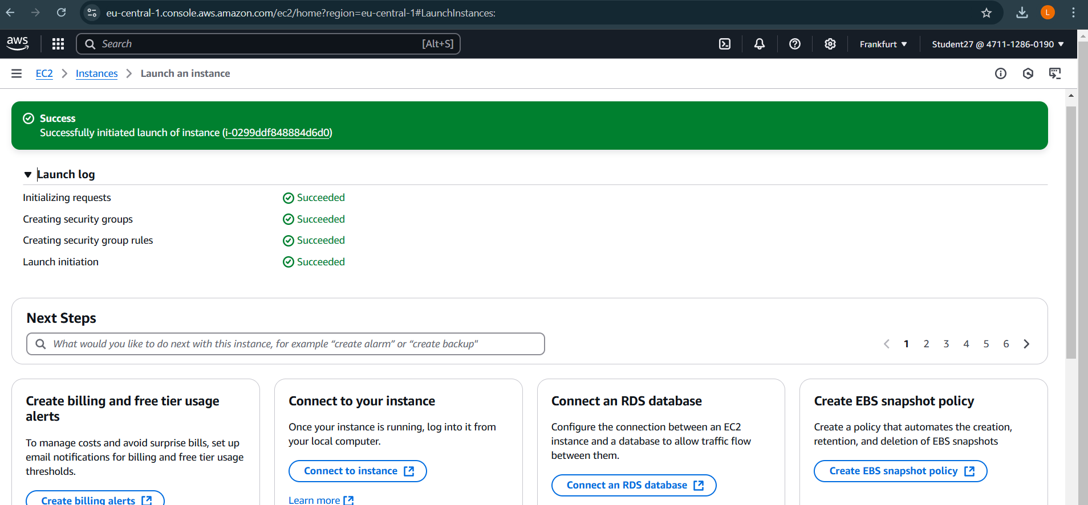

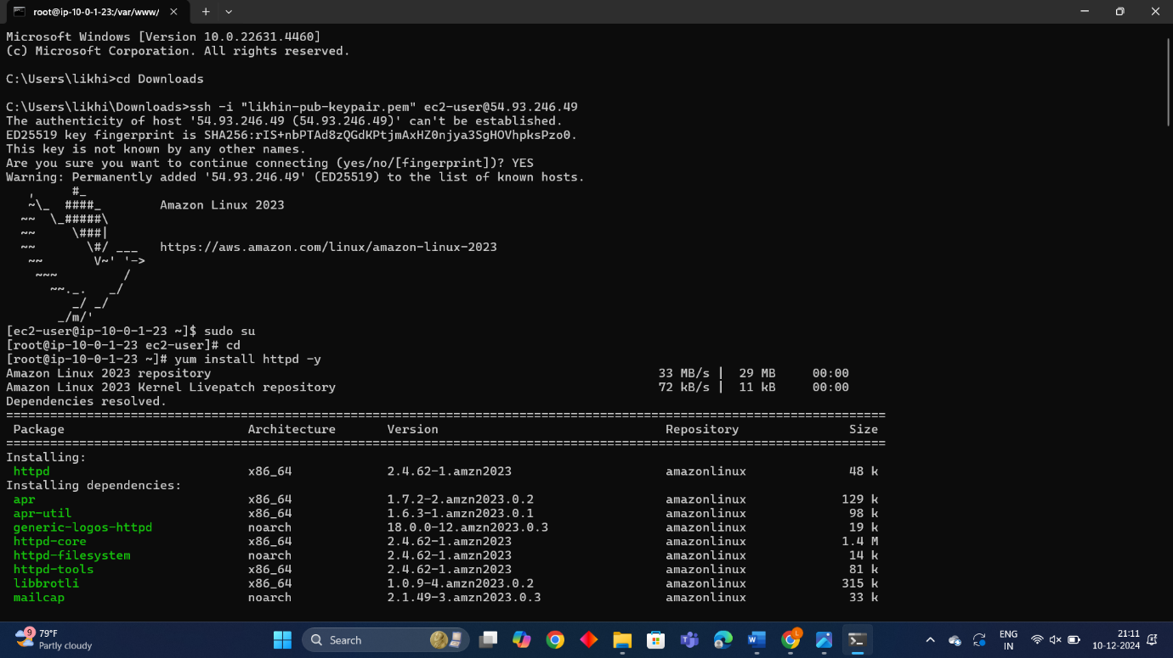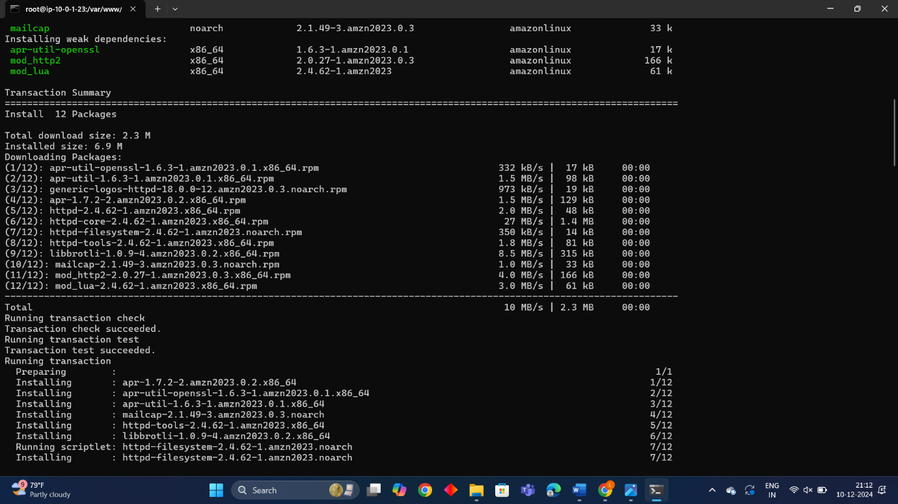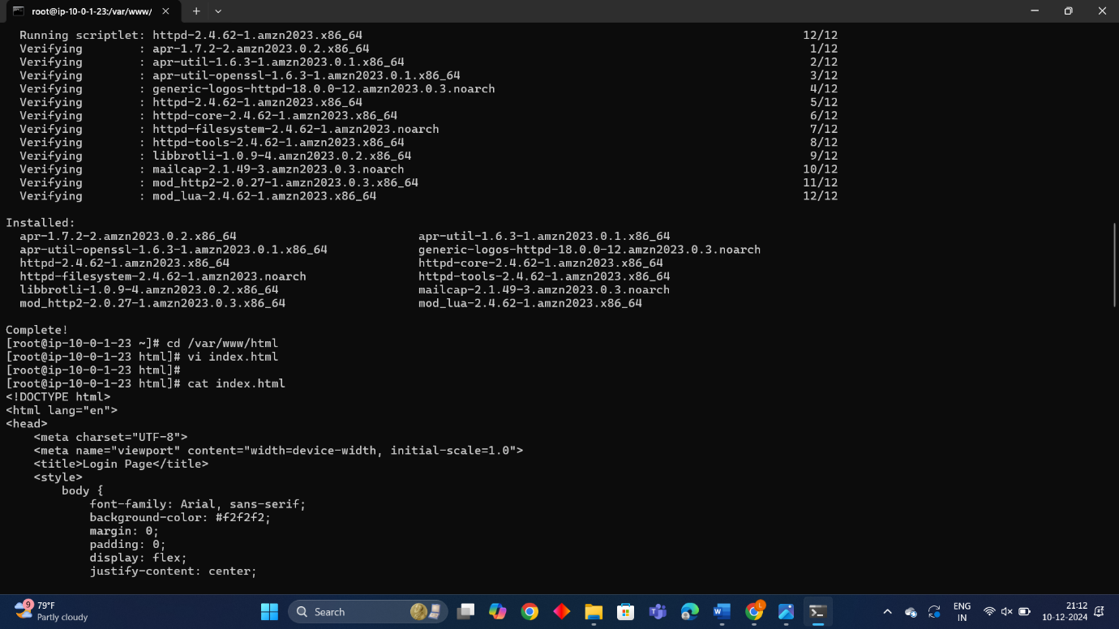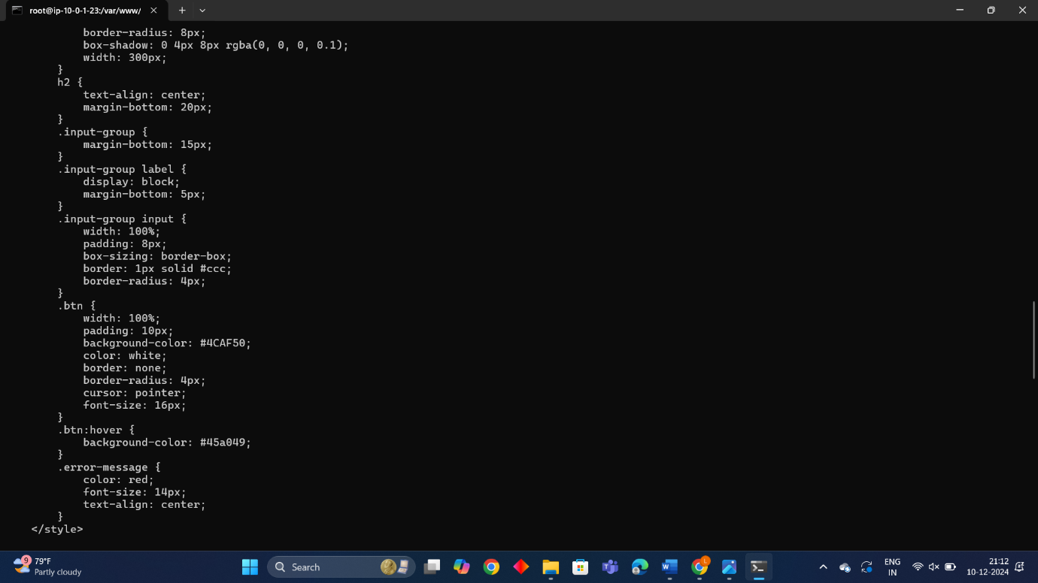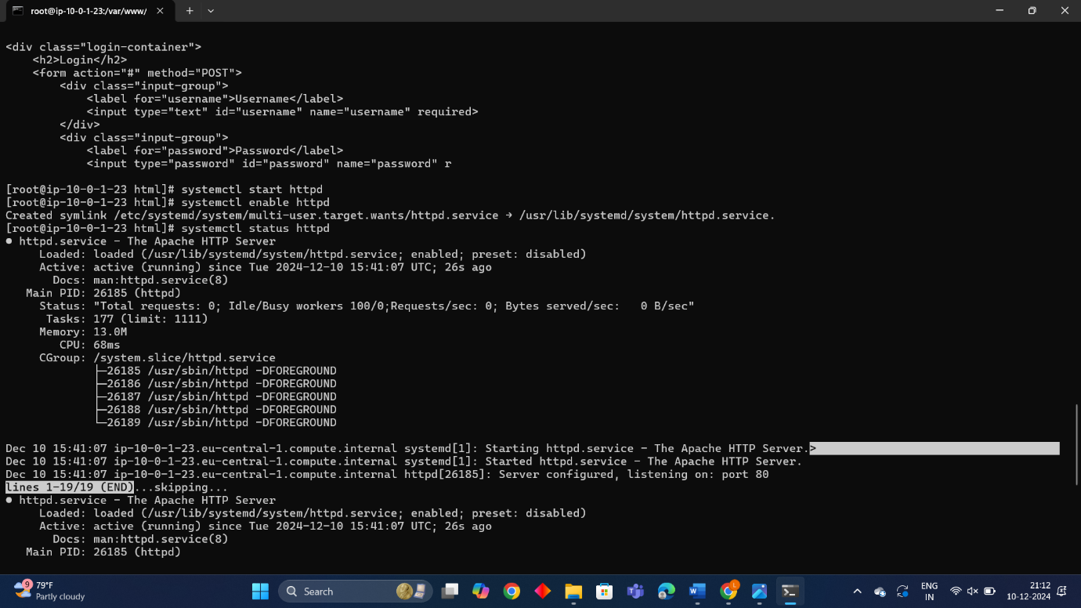

Final Result: 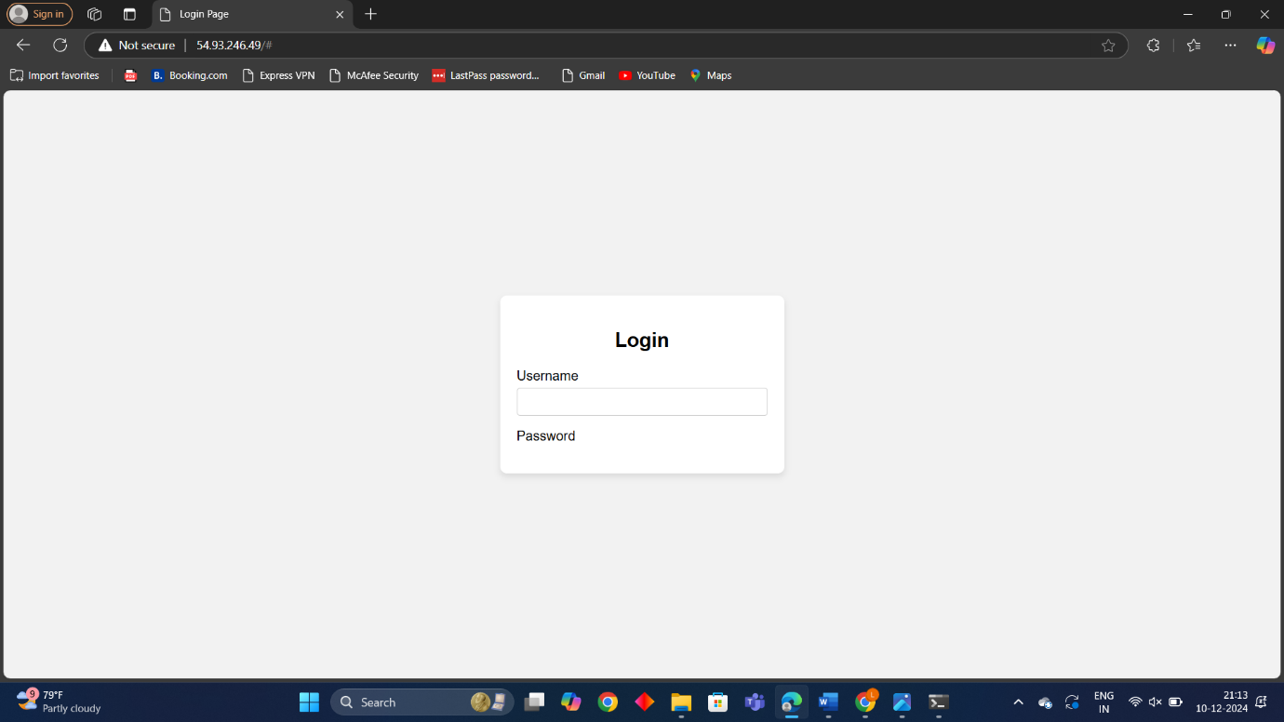

**2.How to create new instances using amazon machine images:**

Creating image:

Steps:

1. To create image using AMI, go to EC2 and click on instances.

2. Select the instance that is created before and click on action.

3. In action, select image and template. In image and template, select create images.

4. Give name as likhin27-server-backup and description to the instances.

Created instance as likhin27-backup-server 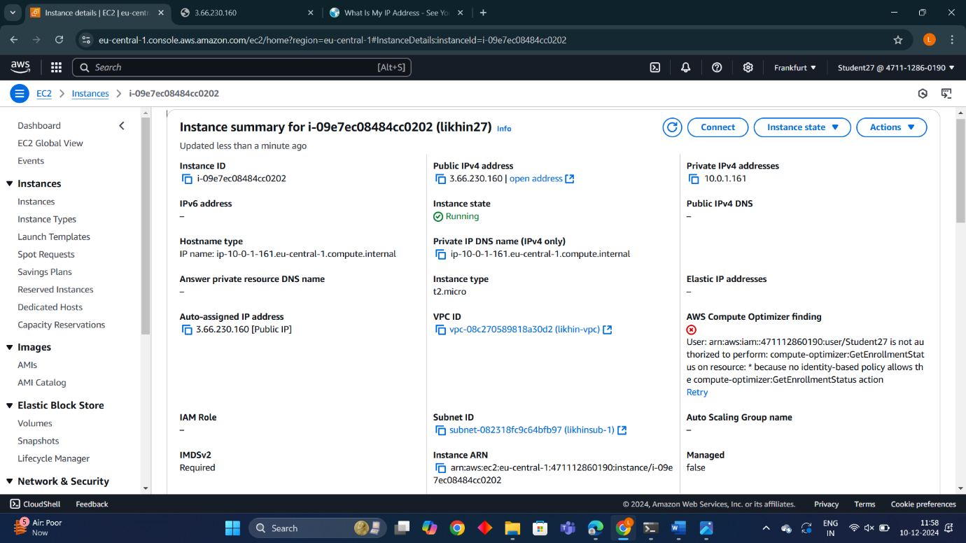

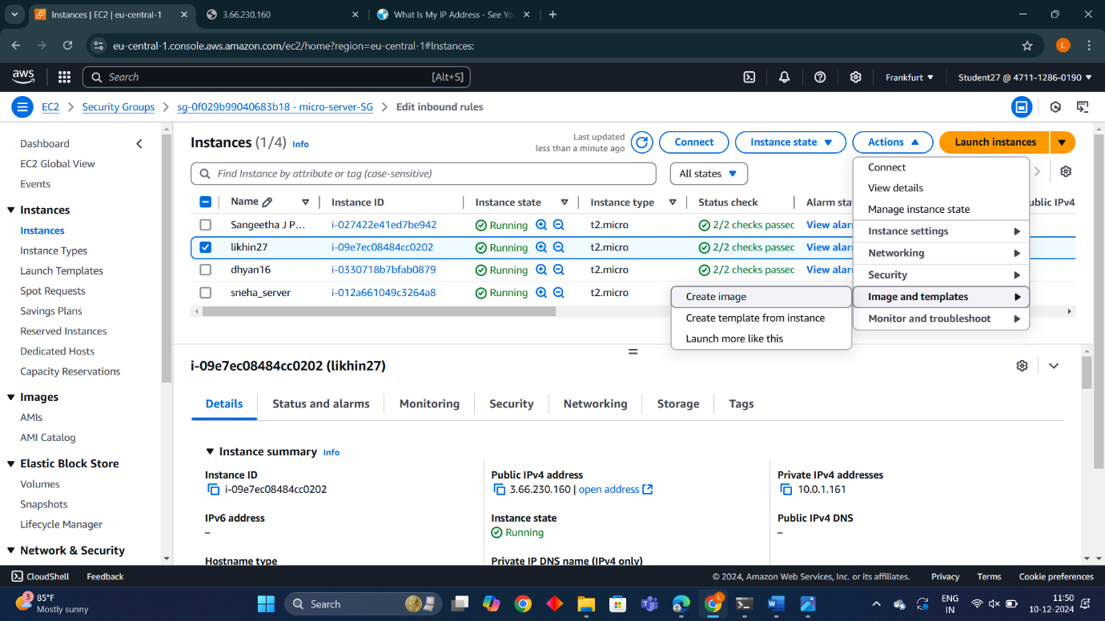

* Created AMI image as likhin27-backup

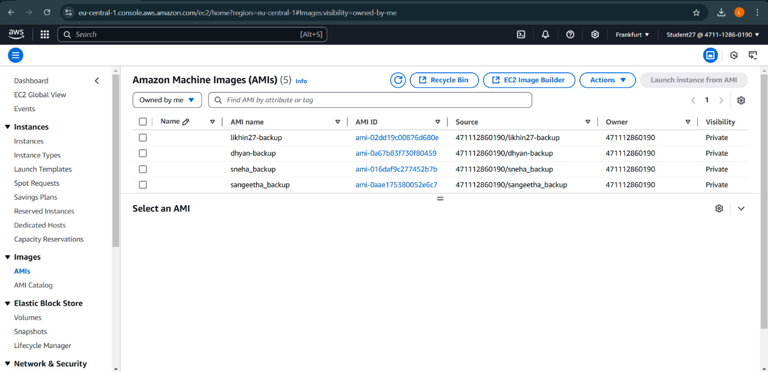

After launching the backup server :

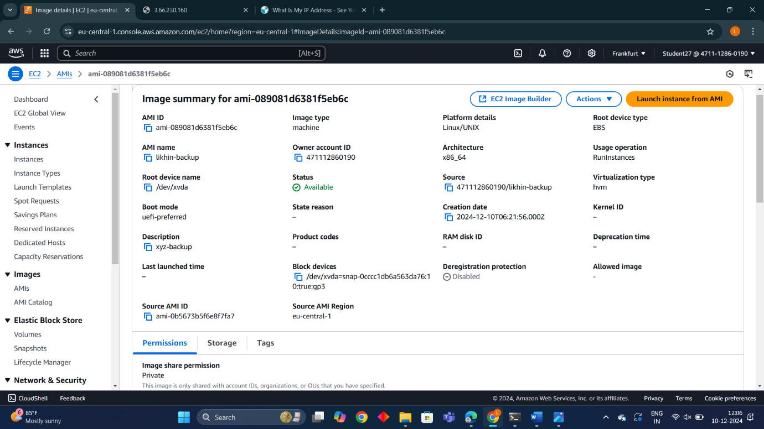

Final Result:

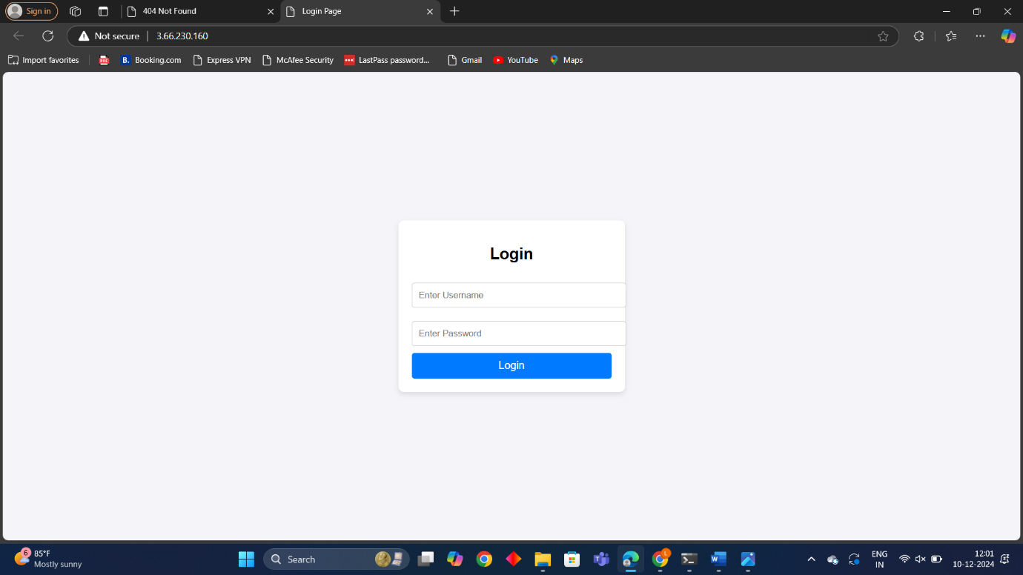

**Project 3**

**How to connect private server to internet using NAT gateway (Jump server/bastion host).**

* **Route table creation:**

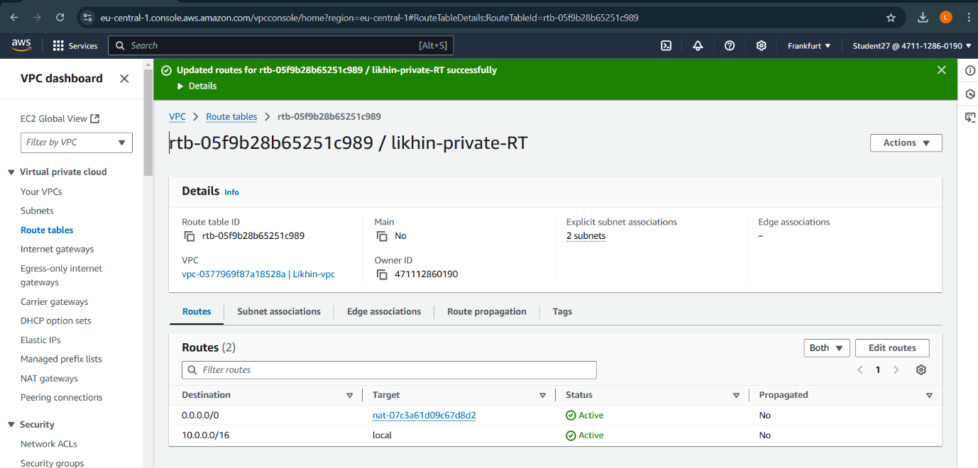

Private subnet : 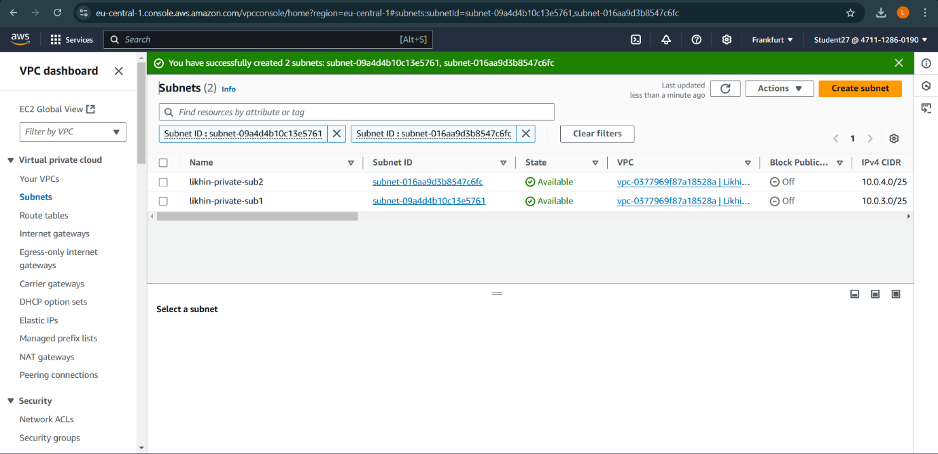

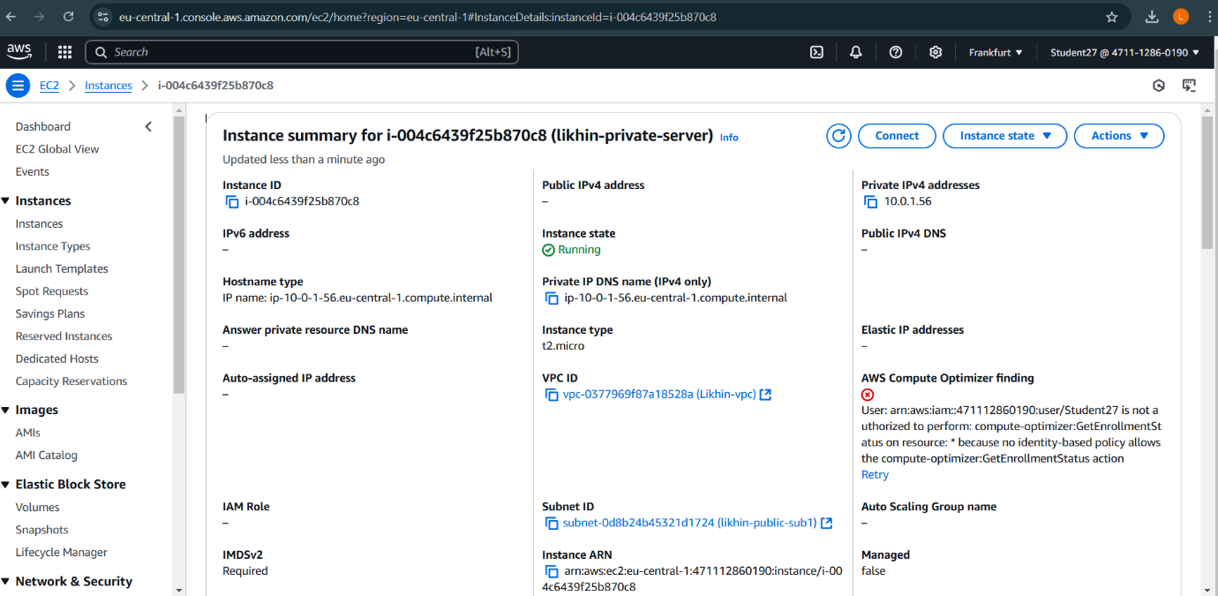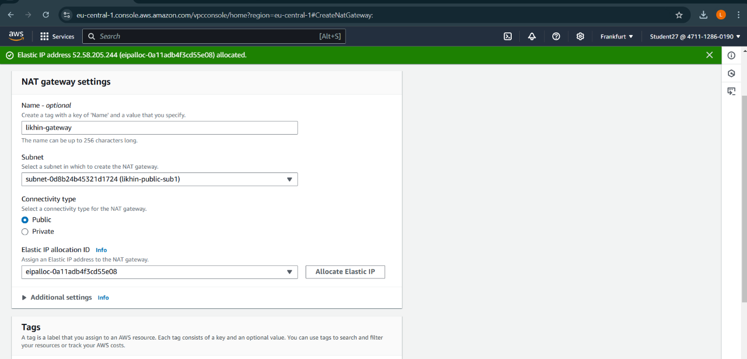

Private route table : 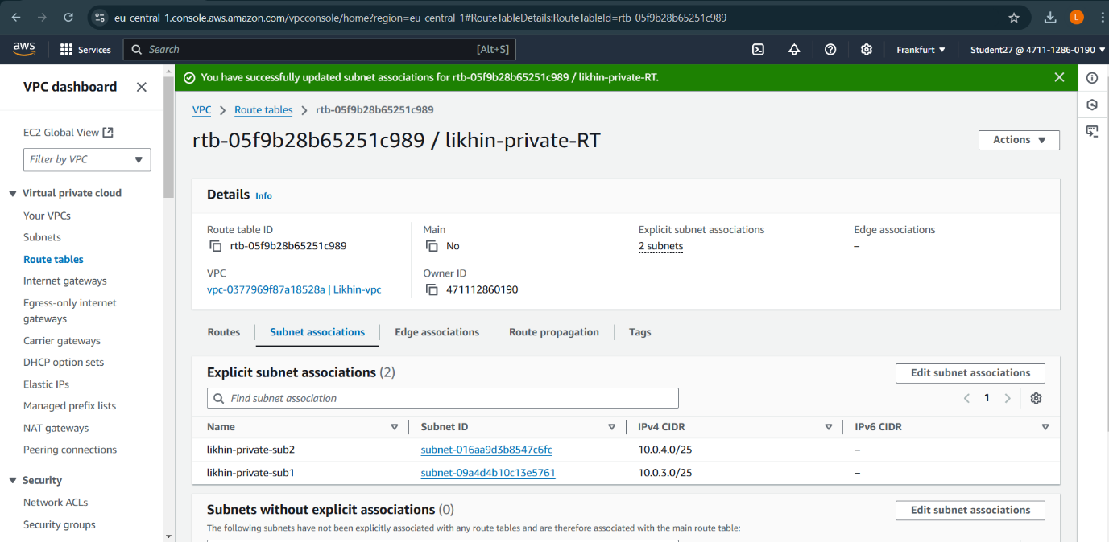

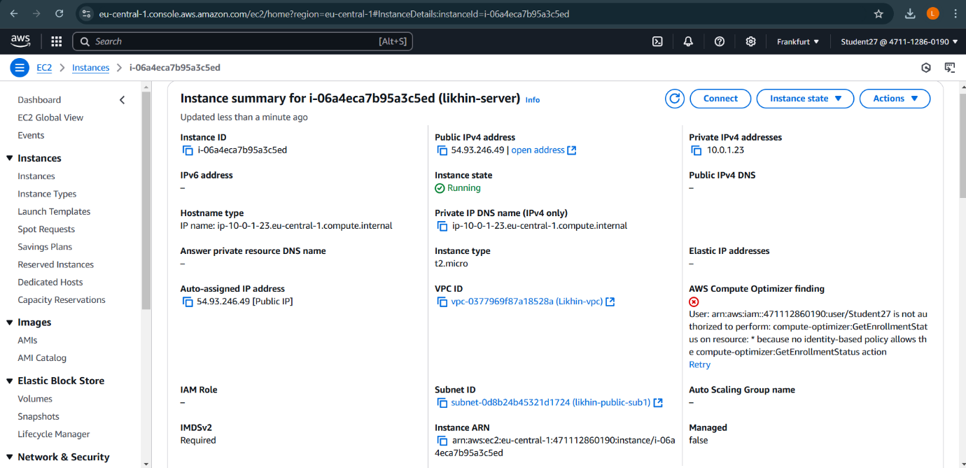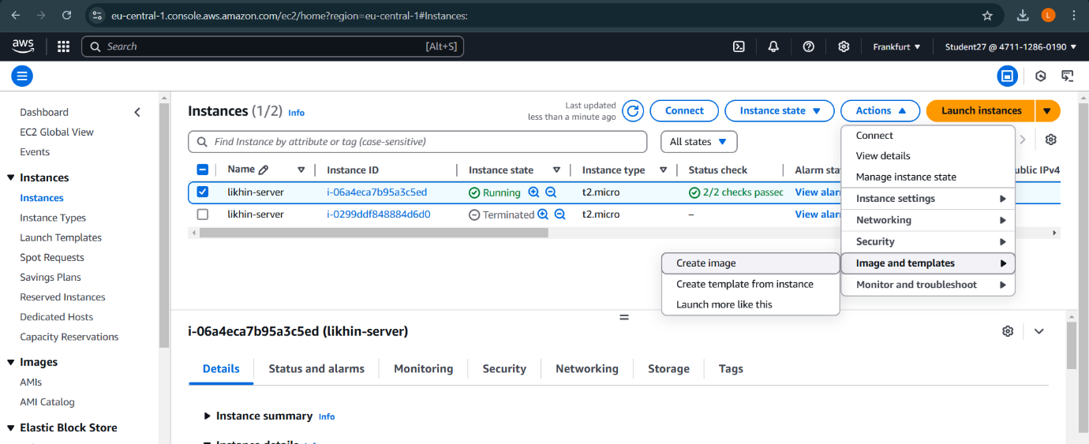

**Command prompts**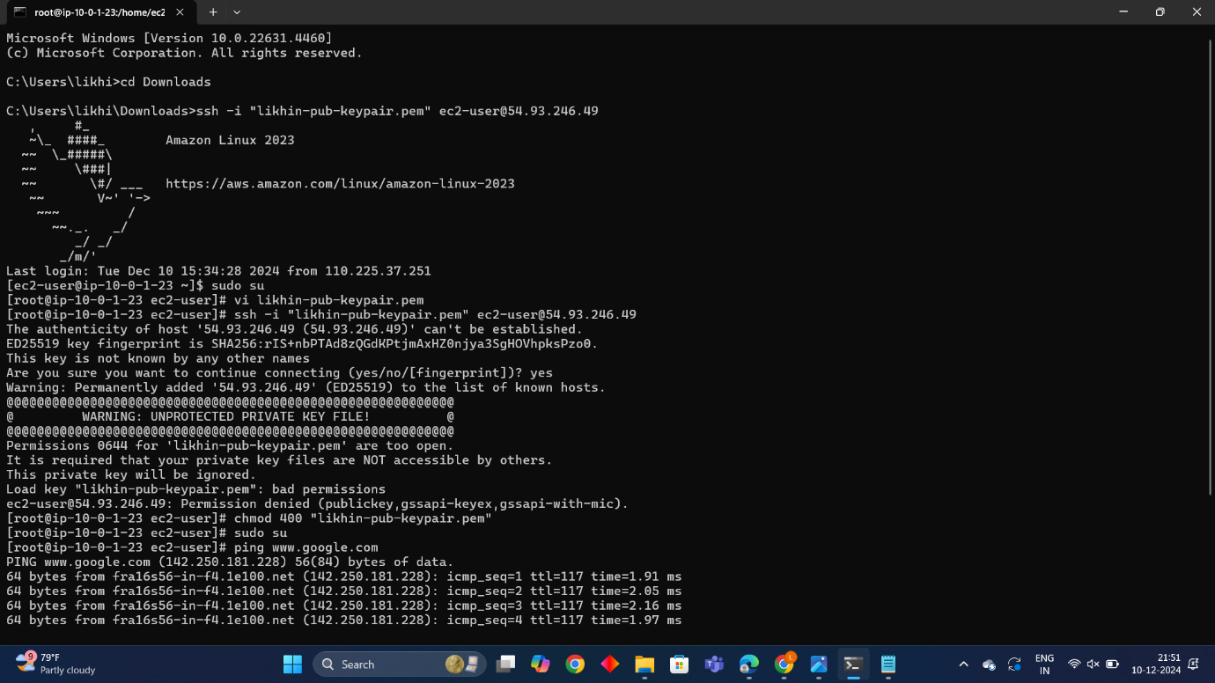

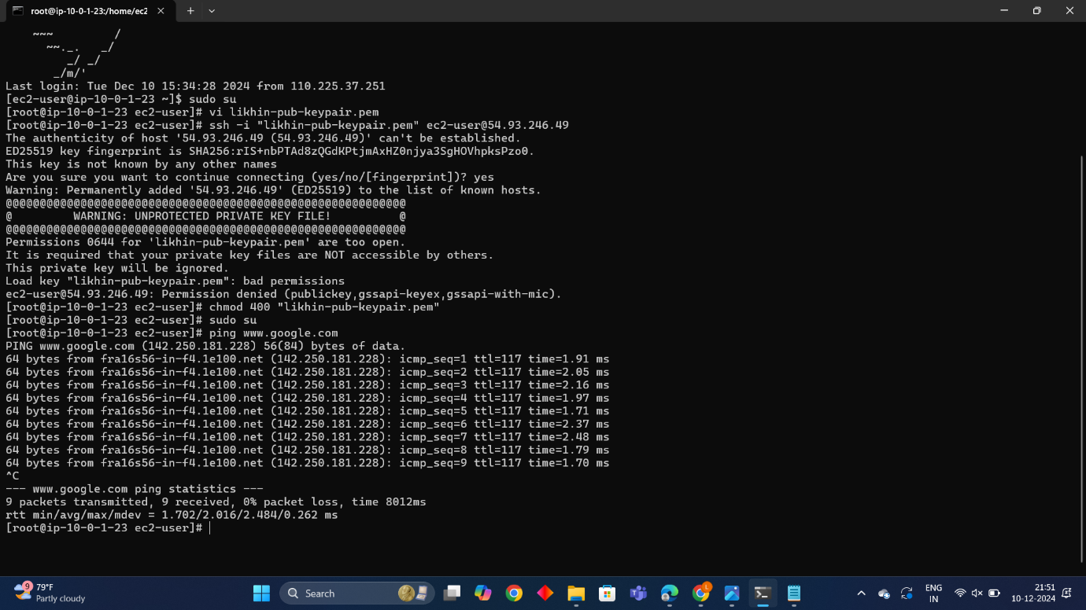

**Project 4**

**Hosting a static website using S3 Bucket.**

S3 bucket

Steps: 1. Go to search bar and type s3. Click on s3.

2. In S3 dashboard, go to general purpose buckets and click on create bucket button.

3. In general configuration, select bucket type as general purpose and give name as likhinbucket1234.

4. Click on create bucket button. Your bucket is created.

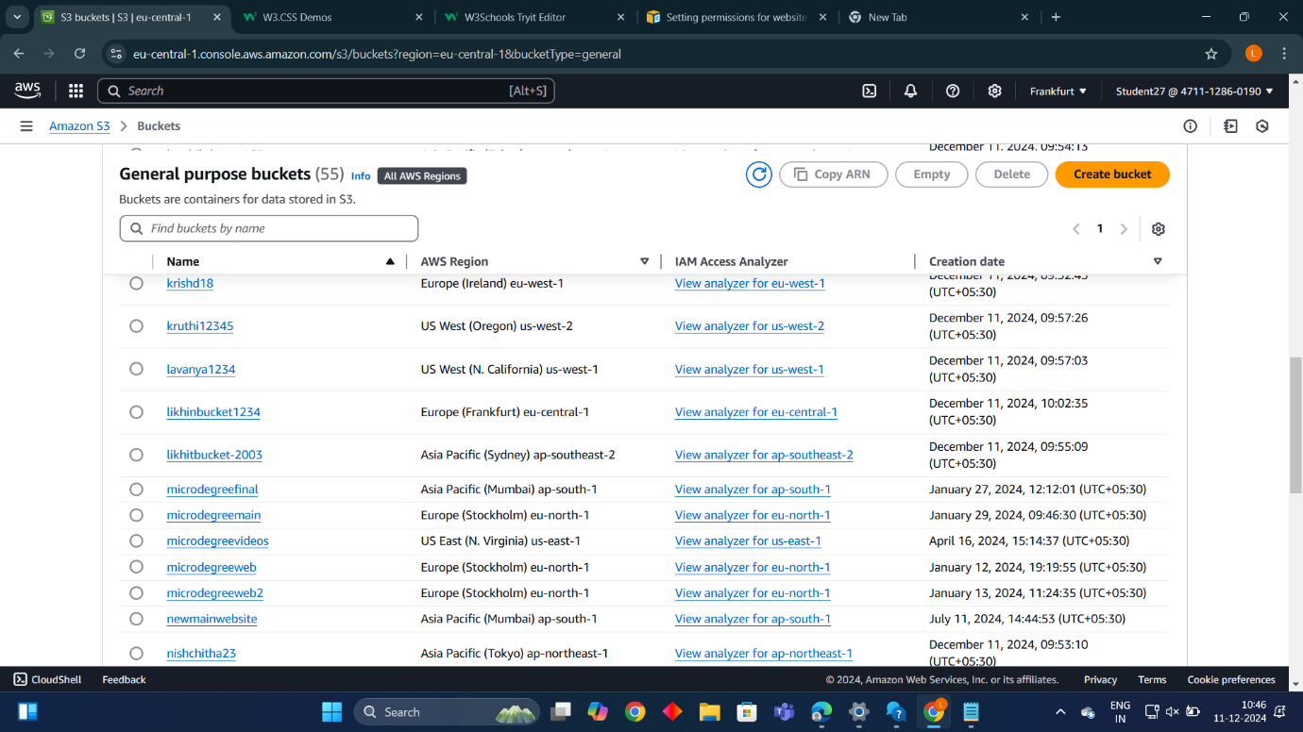

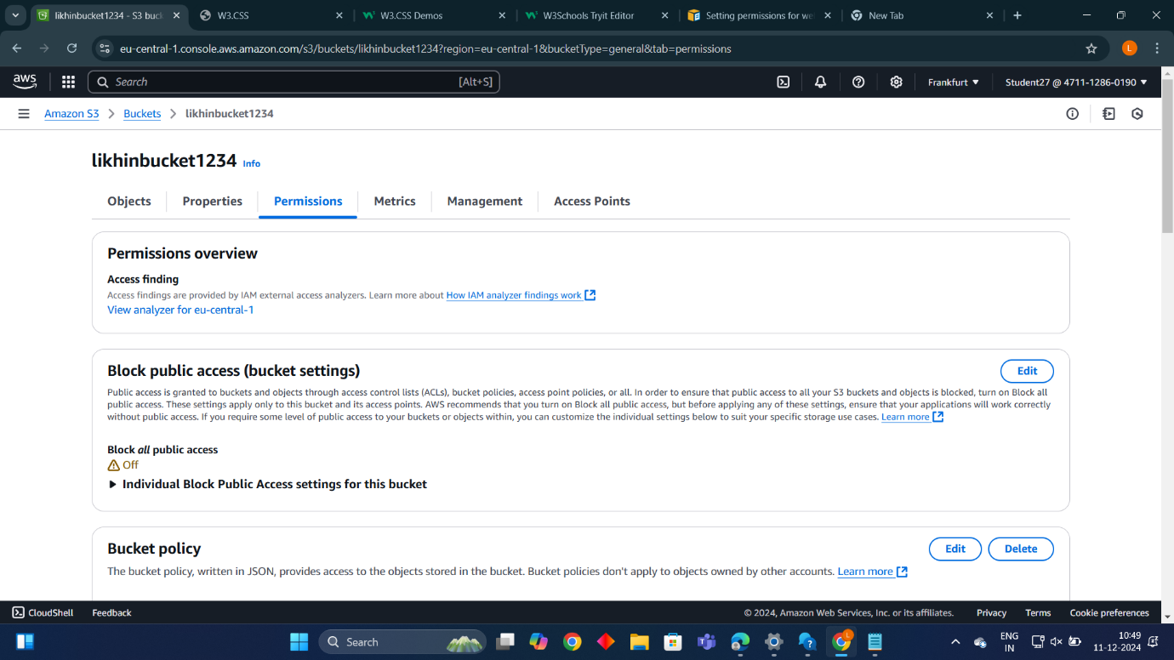

**Uploading a file:**

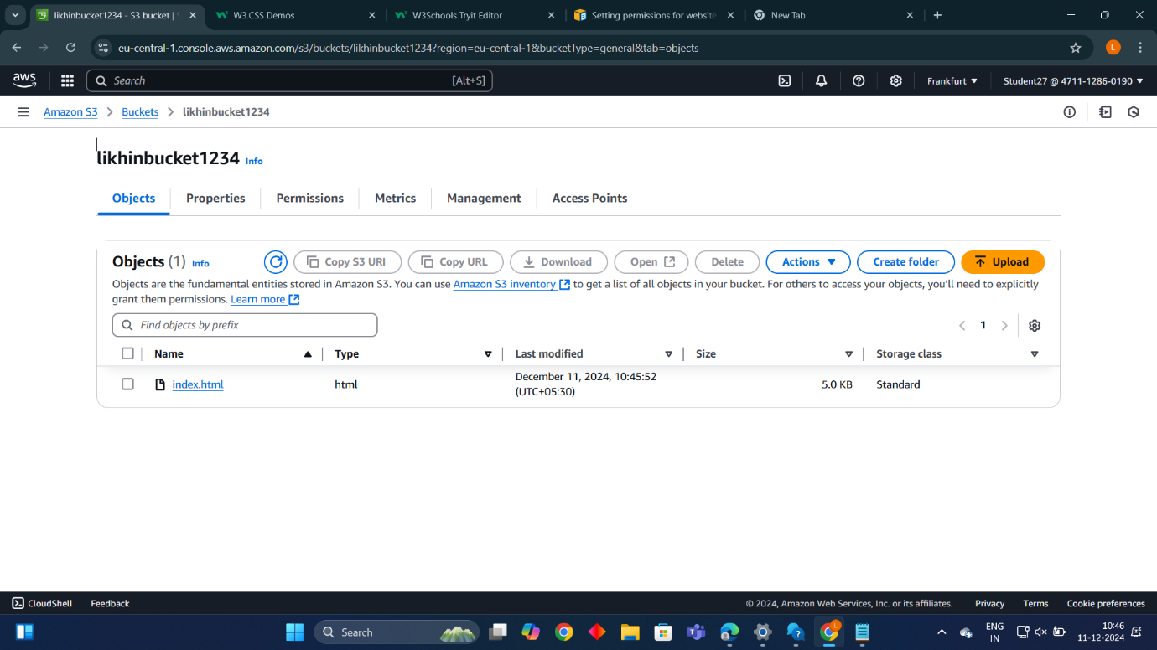

* **Setting permission for website access and add bucket policy:** 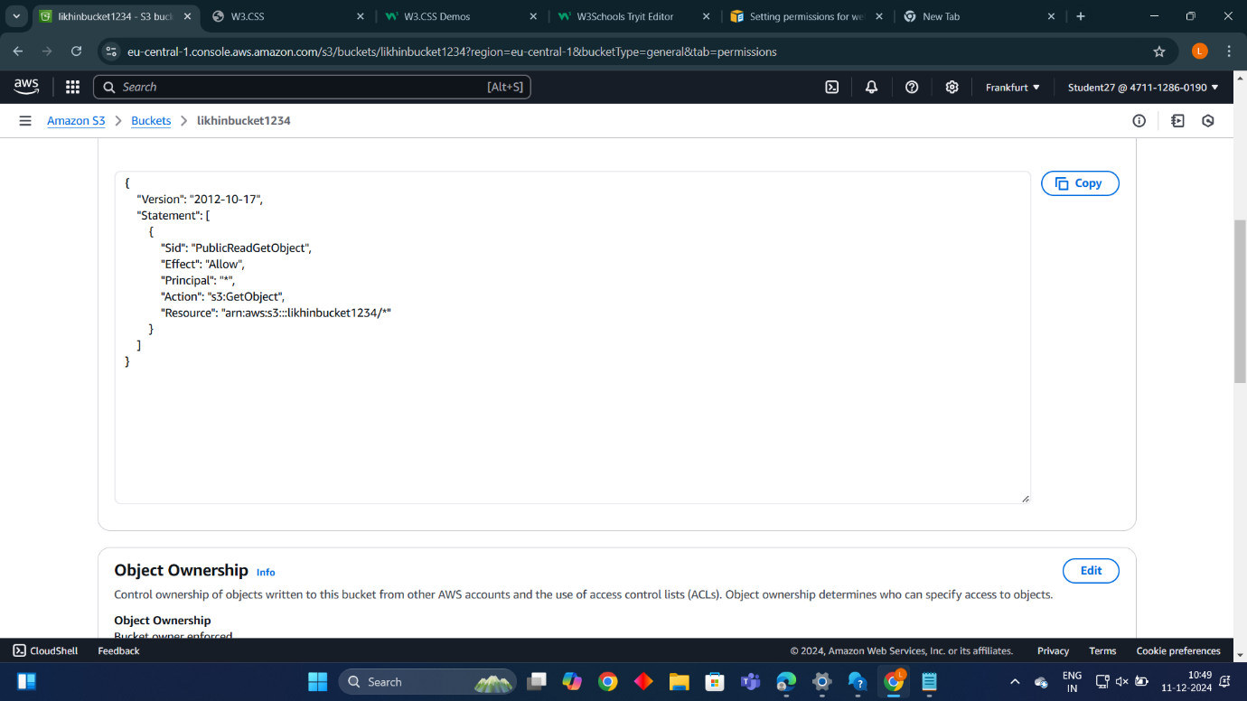
* **Static website hosting:** 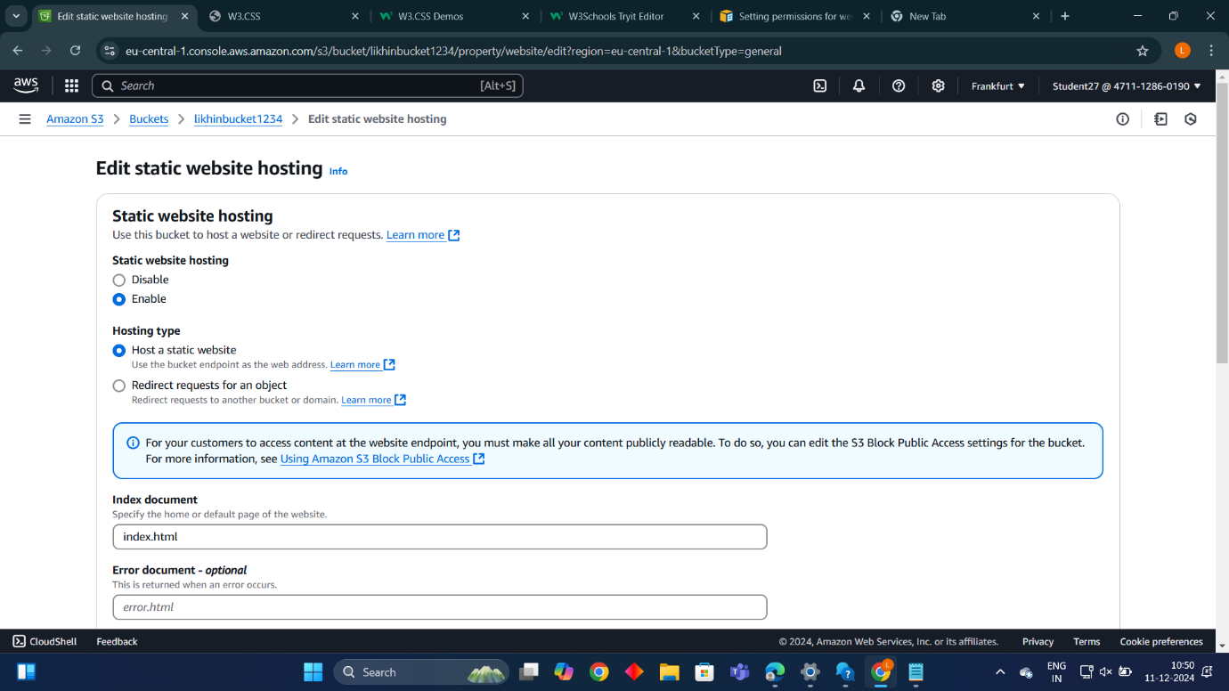

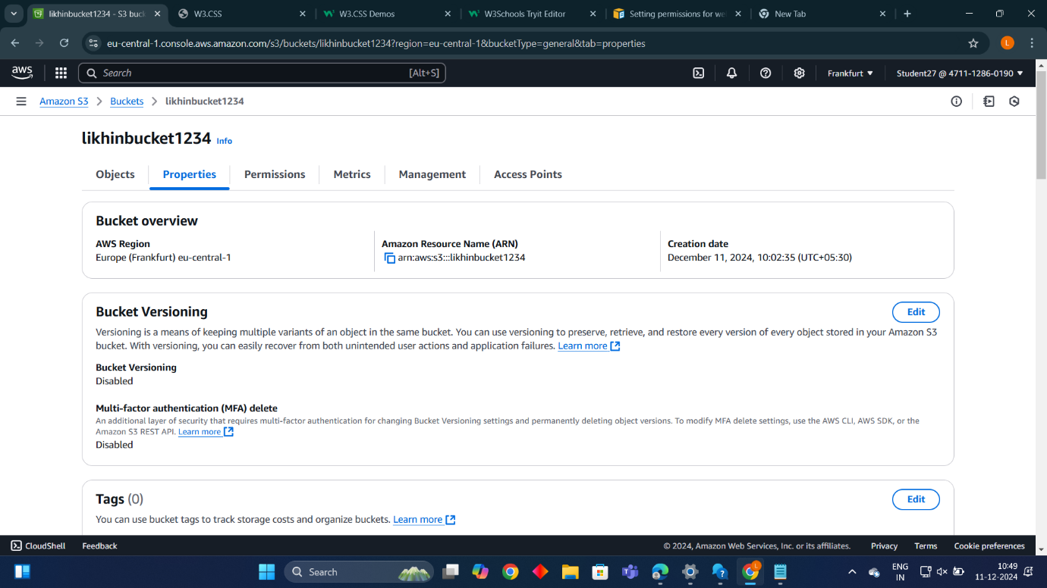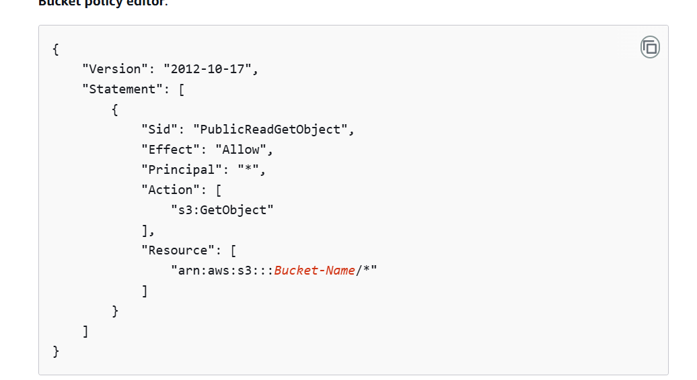

* **Final output**

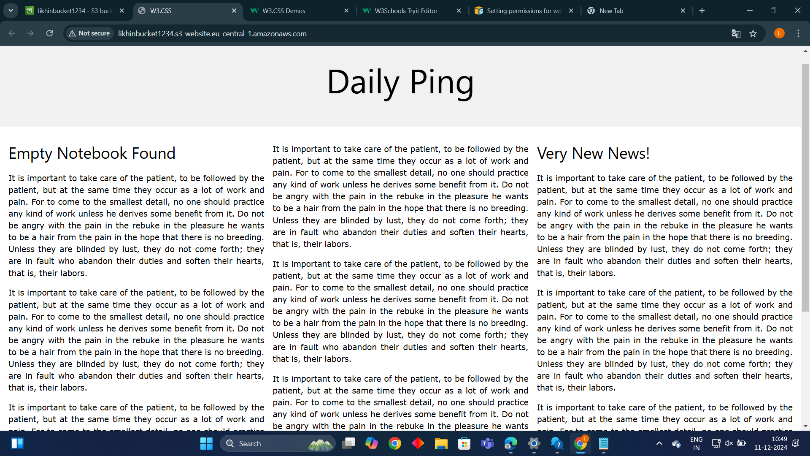

Project 5

Launching the website using Load Balancer DNS name

VPC:

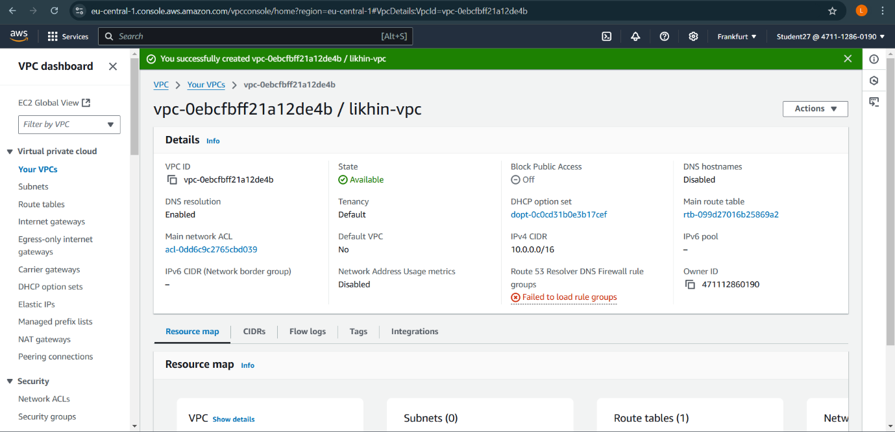

Internet gateway

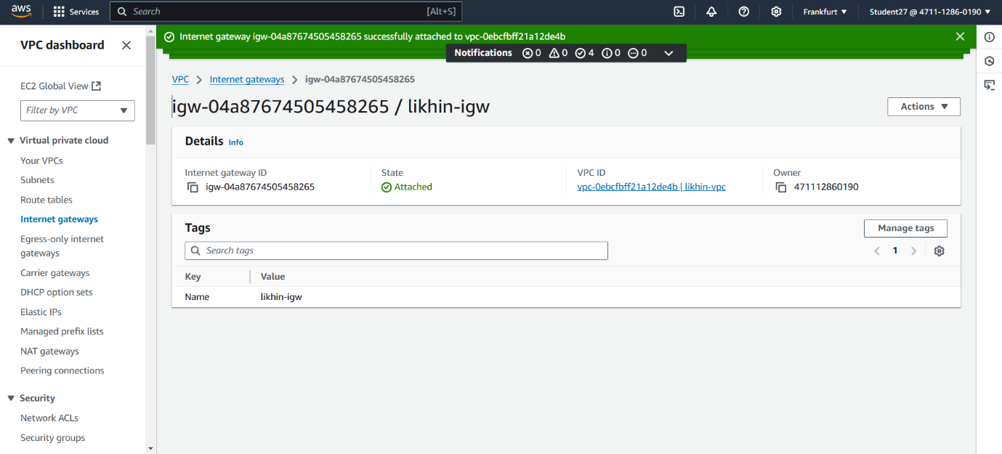

* **Subnet**

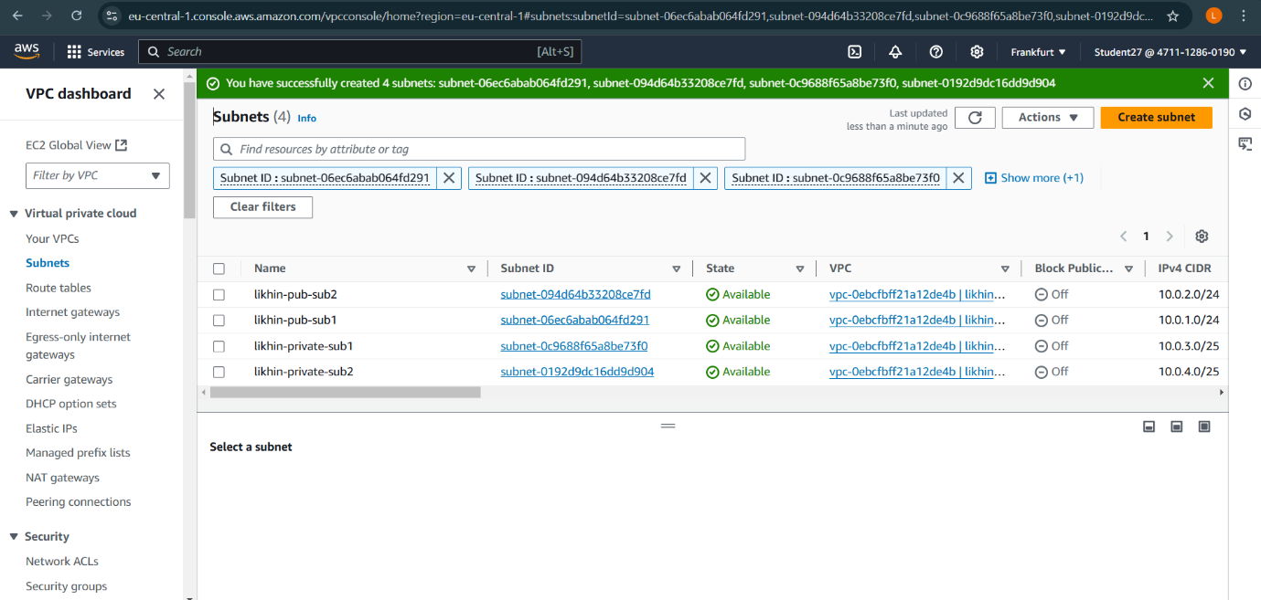

* **Route table**

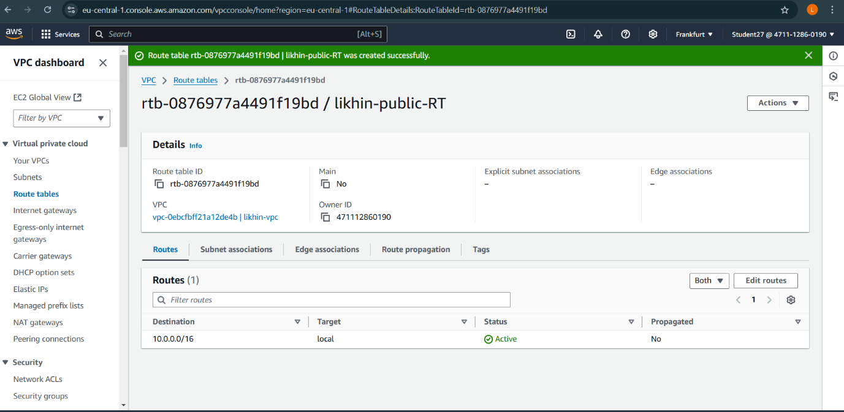

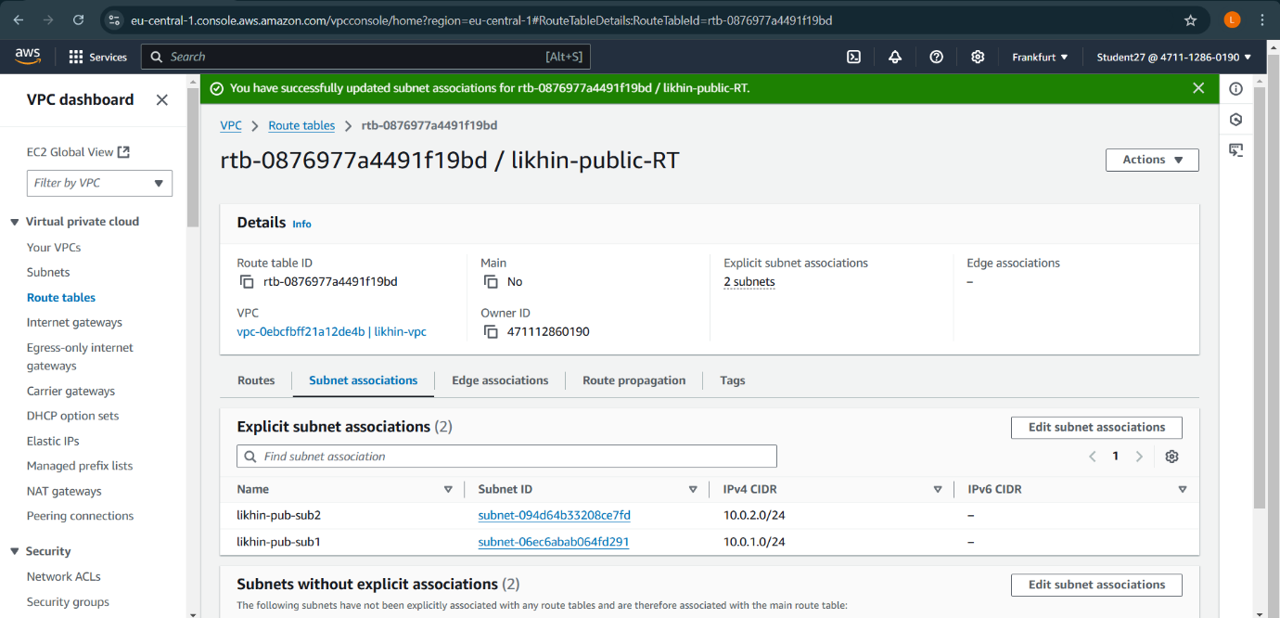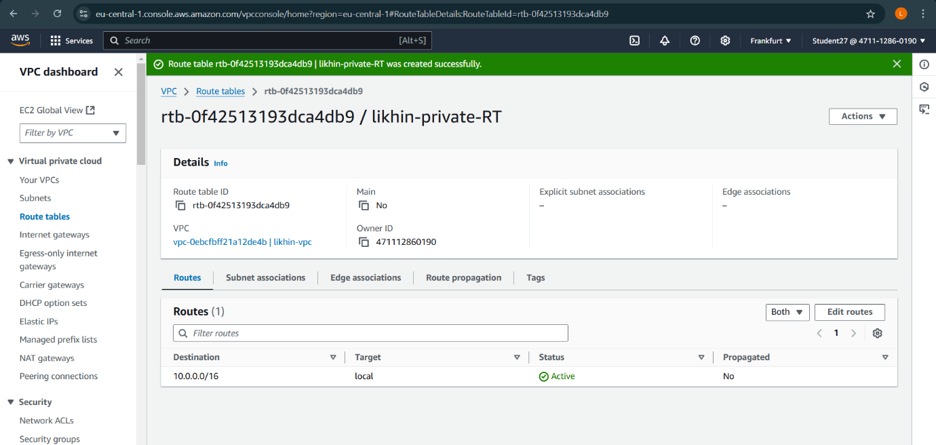

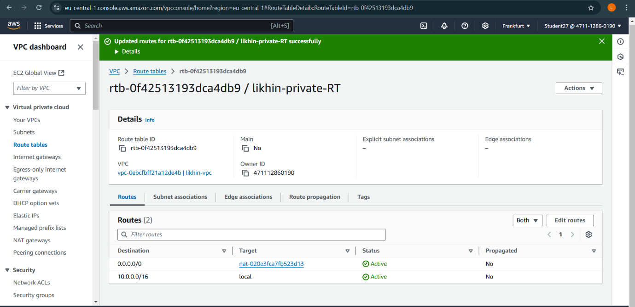

* **Instance**

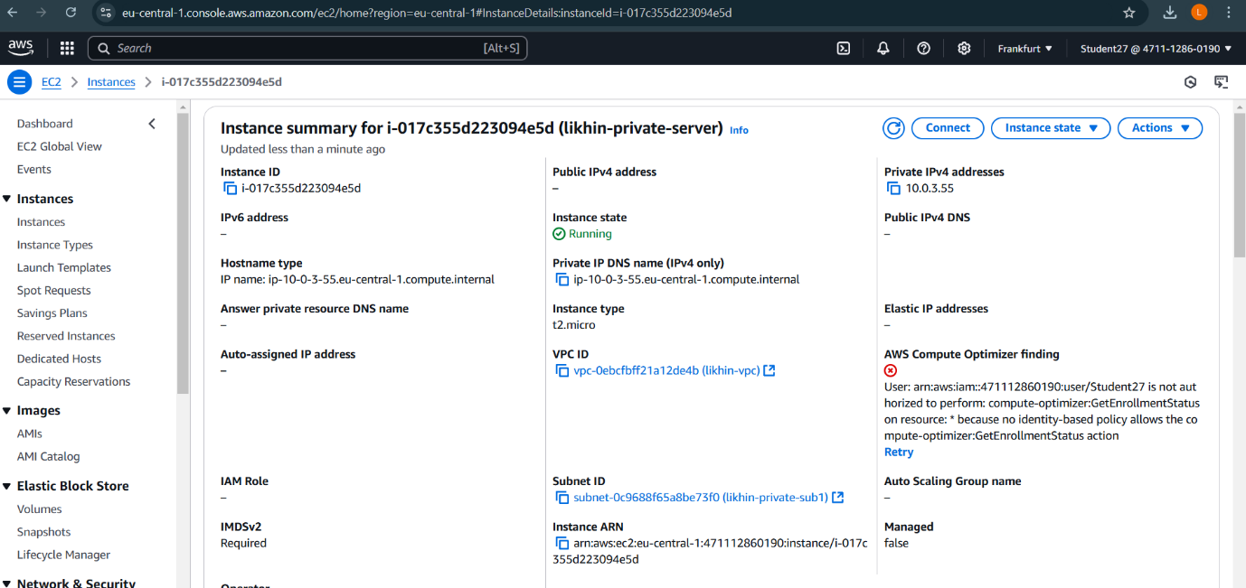

Security Group

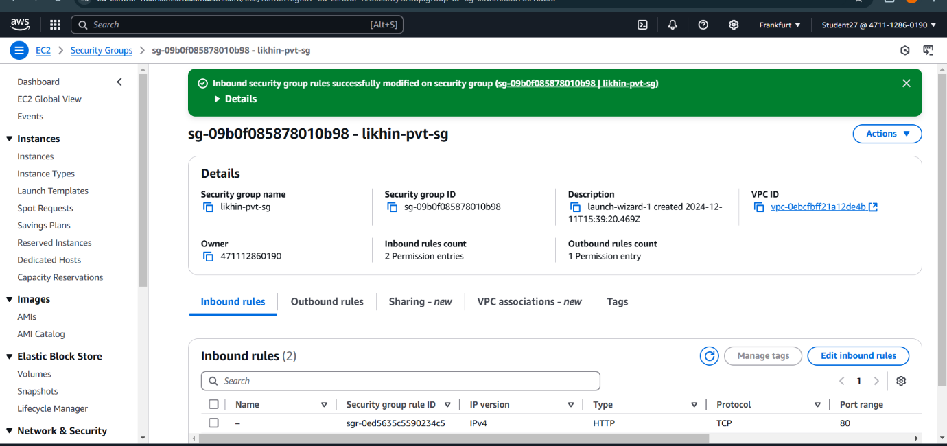

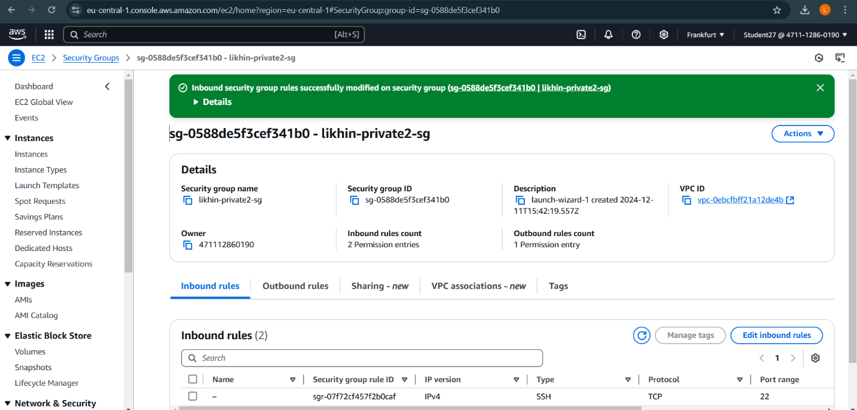

Target Group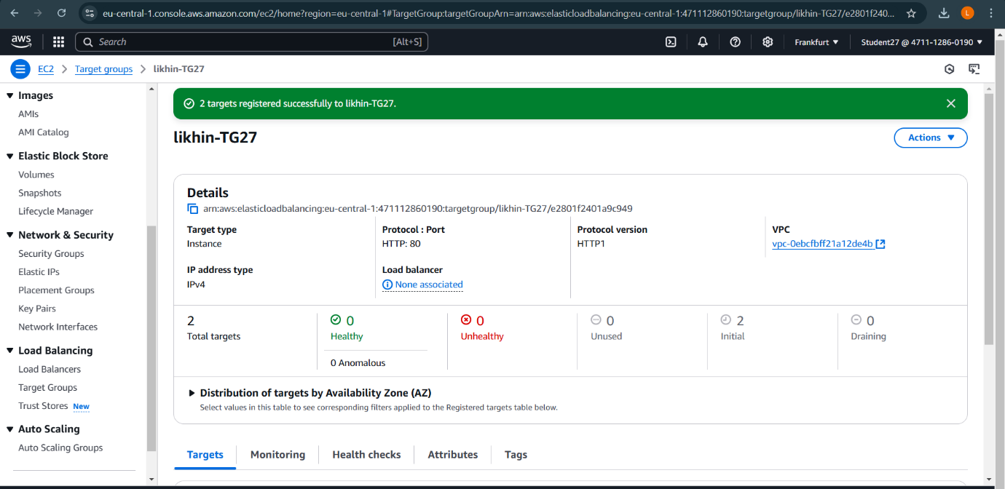

Load Balanacer:  
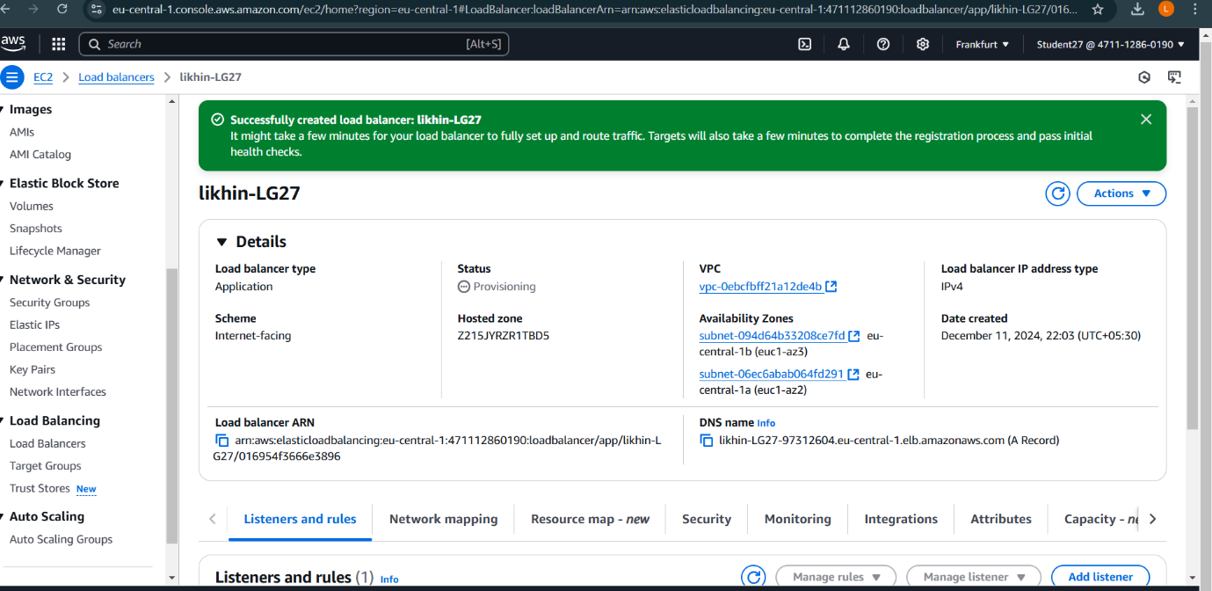

Comand Prompt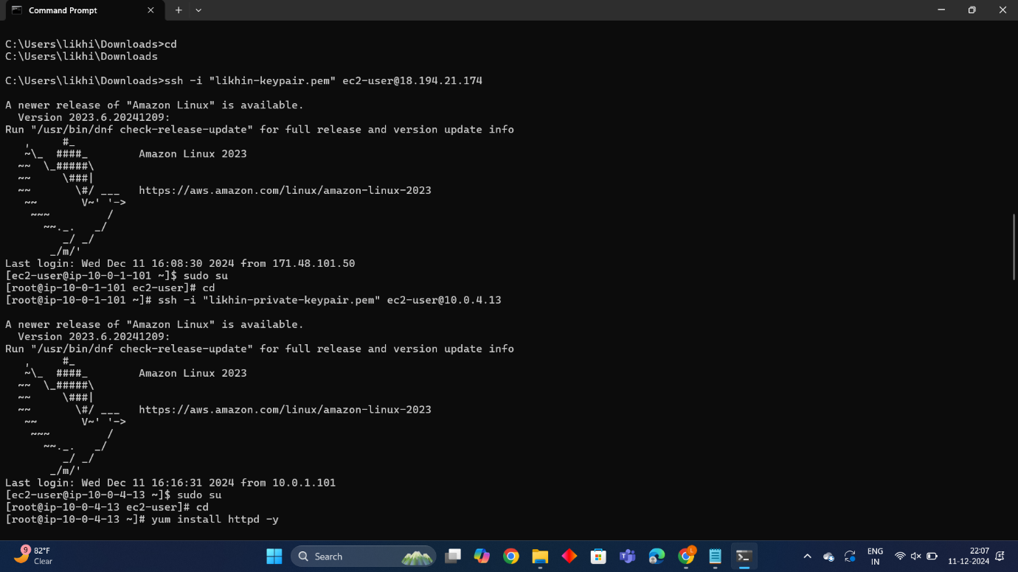

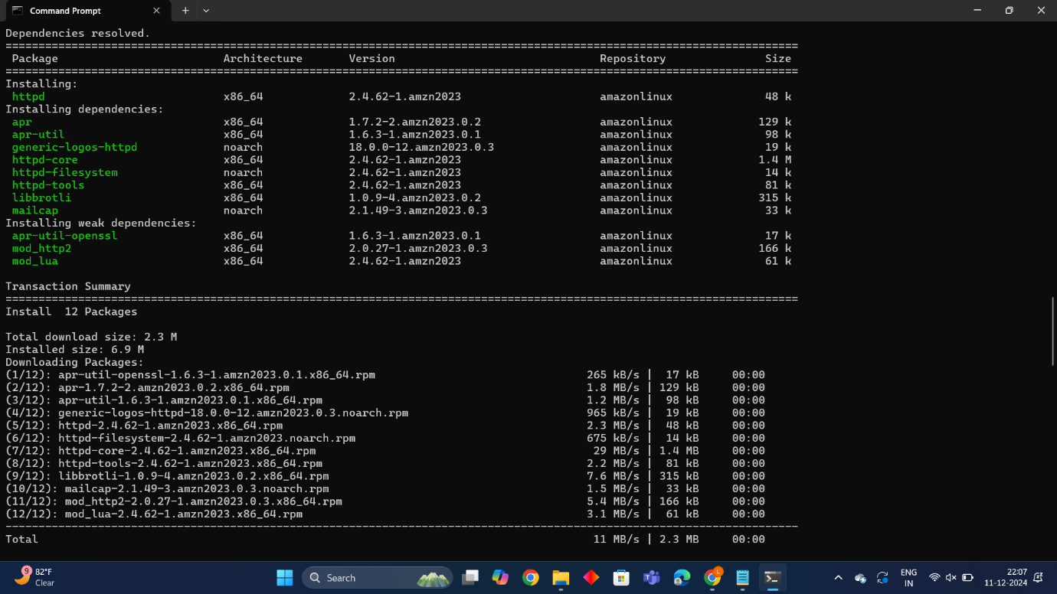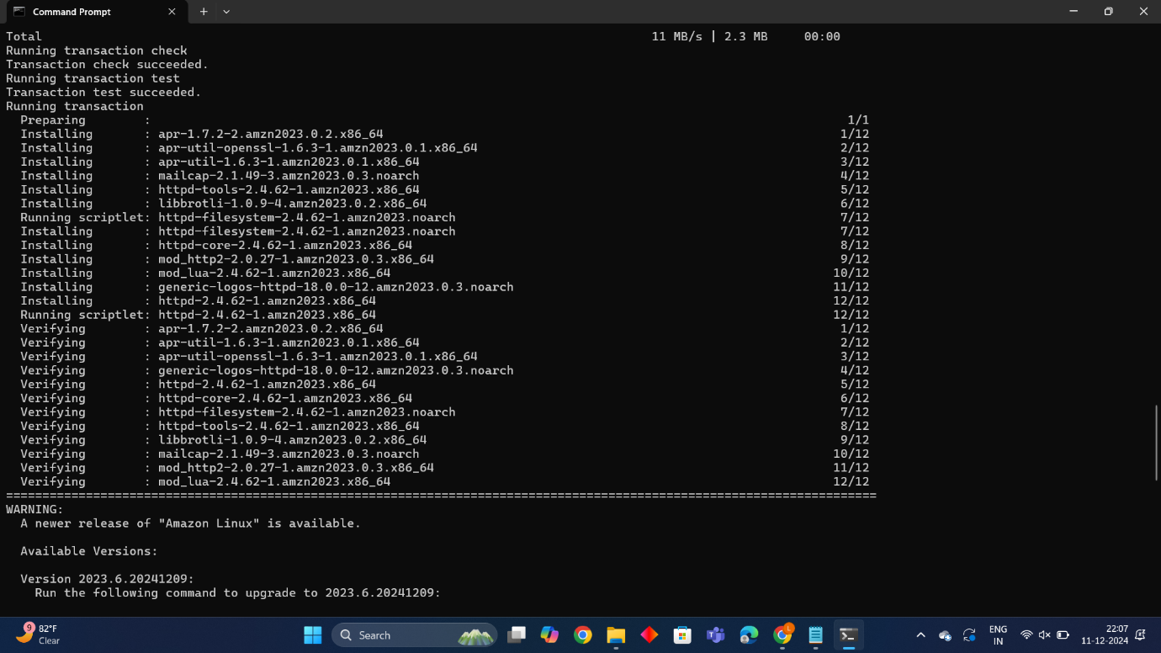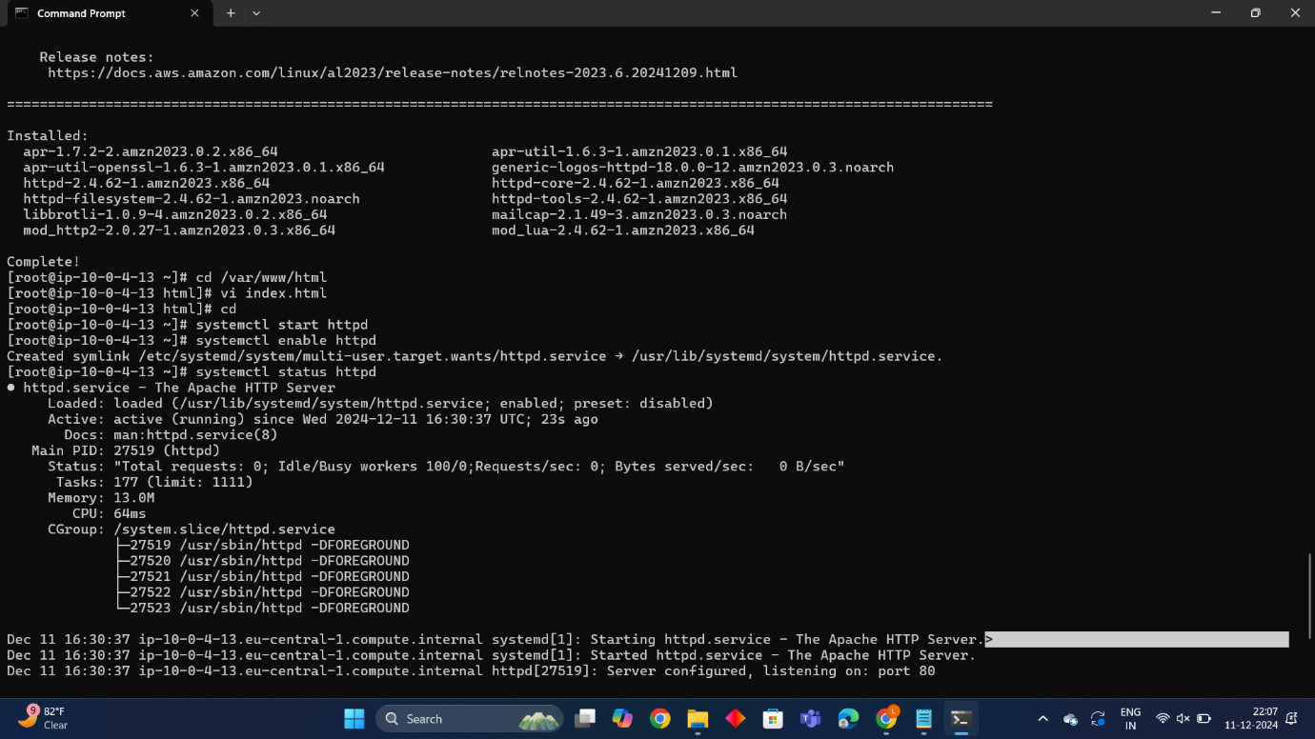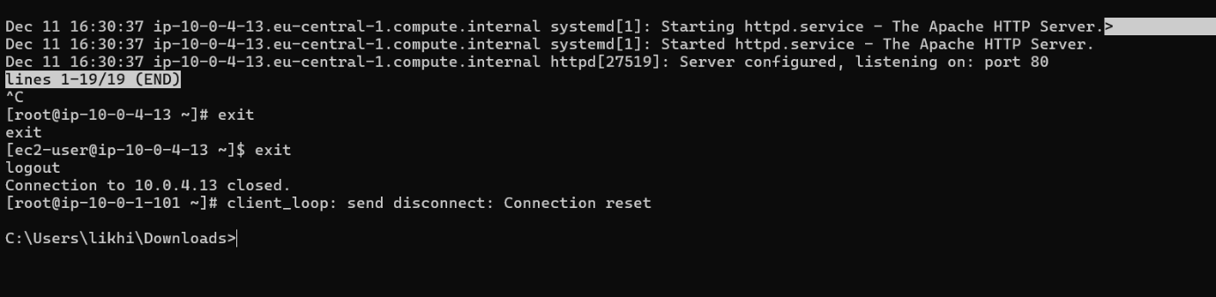

* **Final output:**

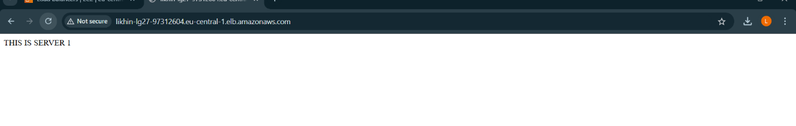

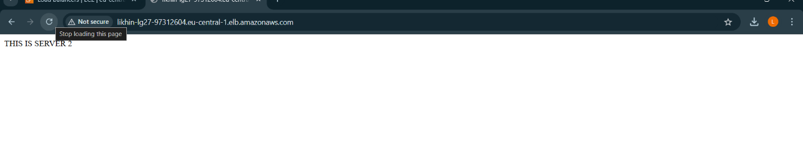

**Project 6**

**How to create a repository in GitHub**

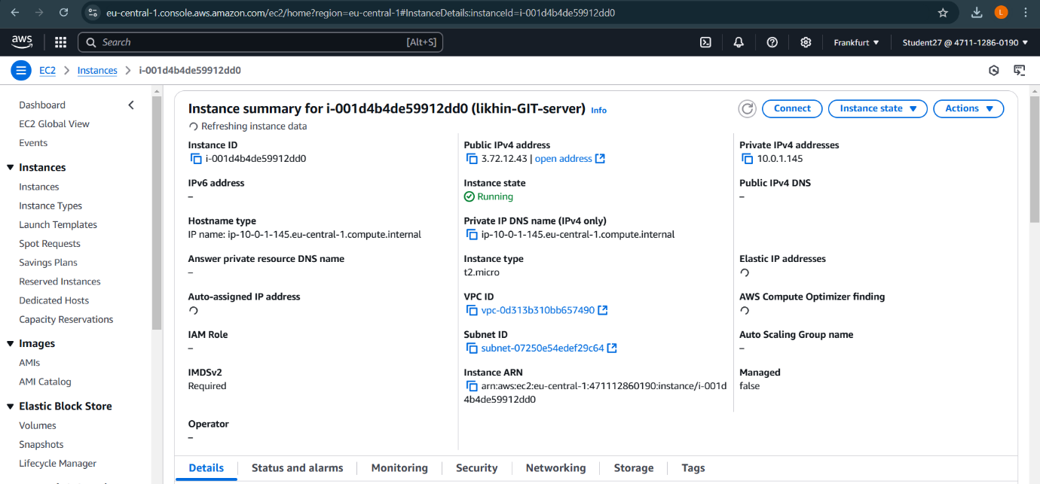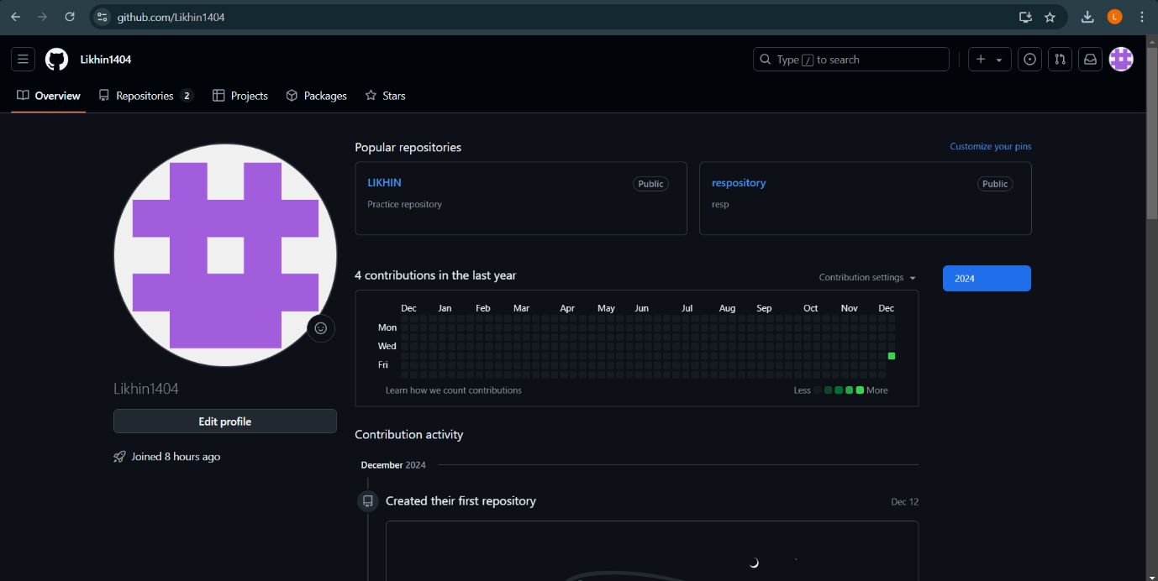

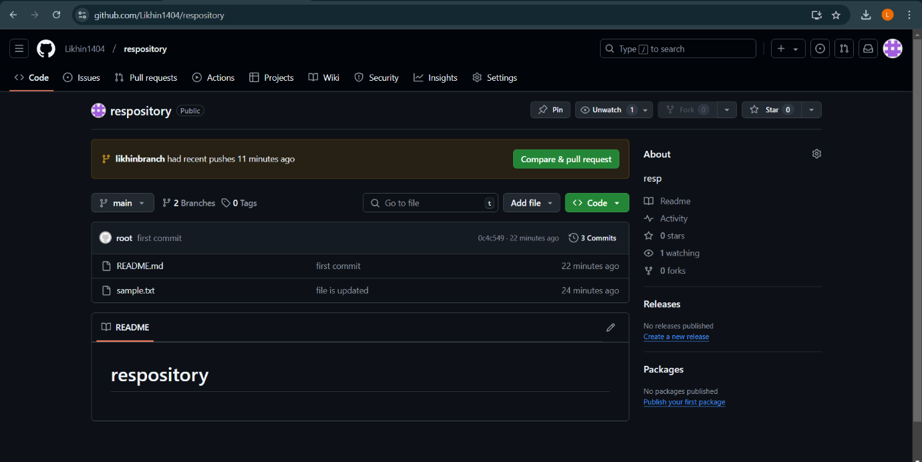

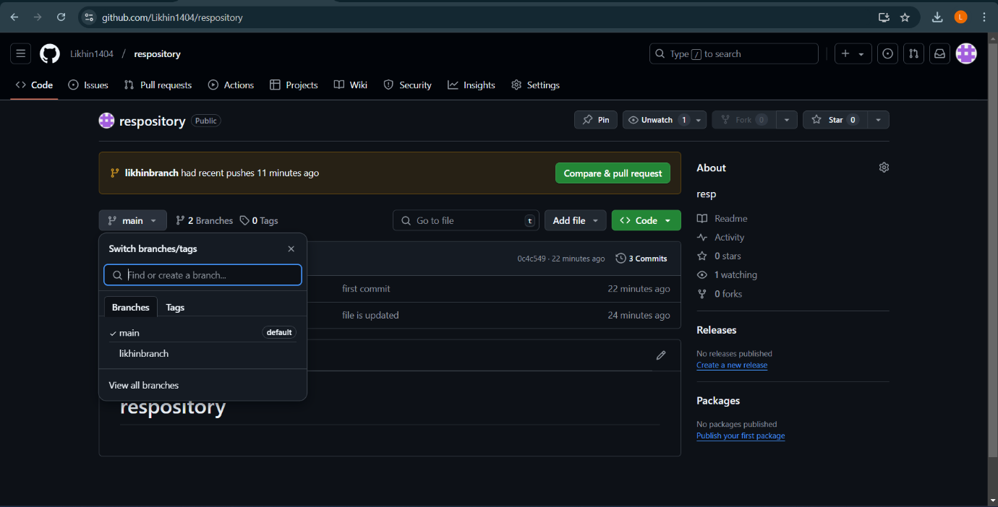

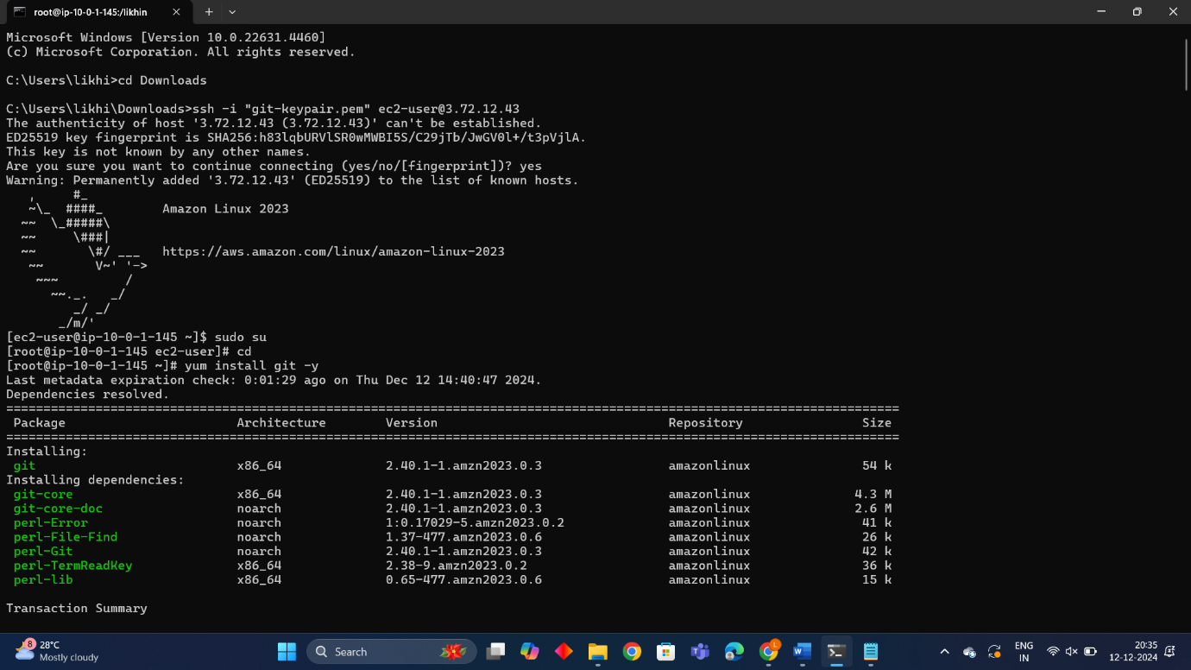

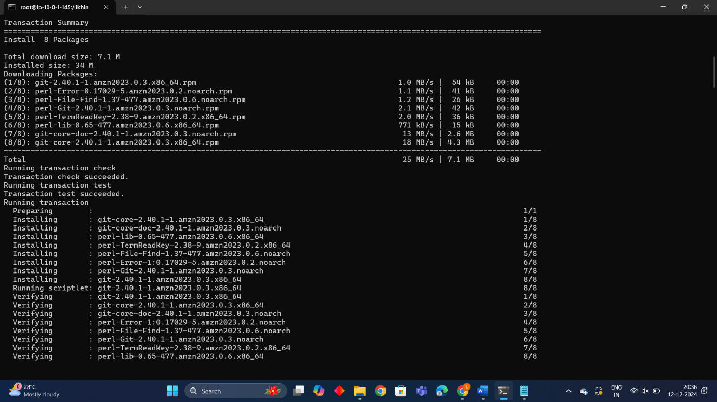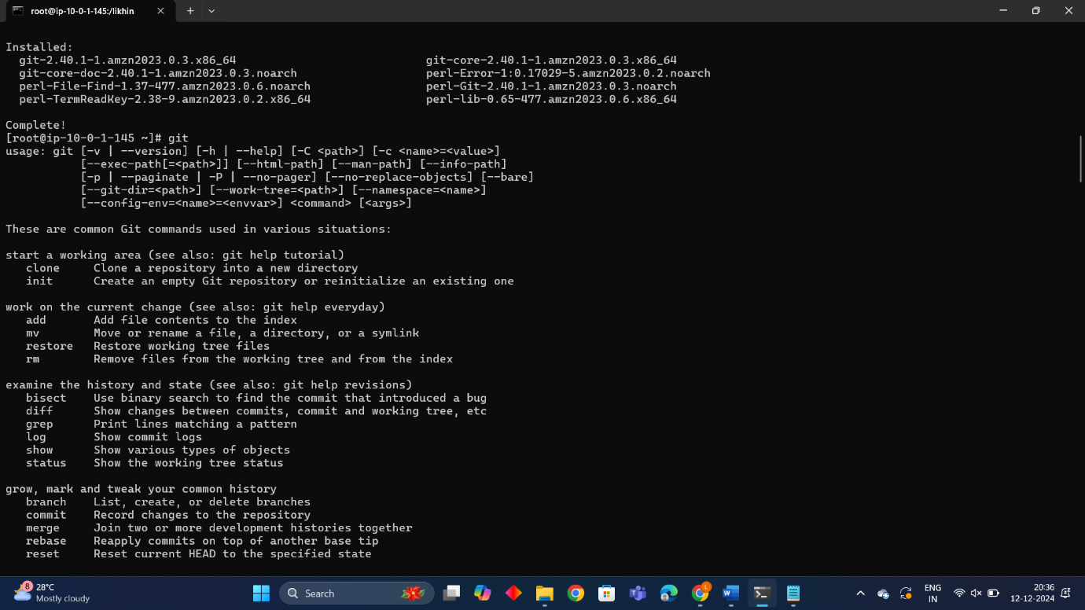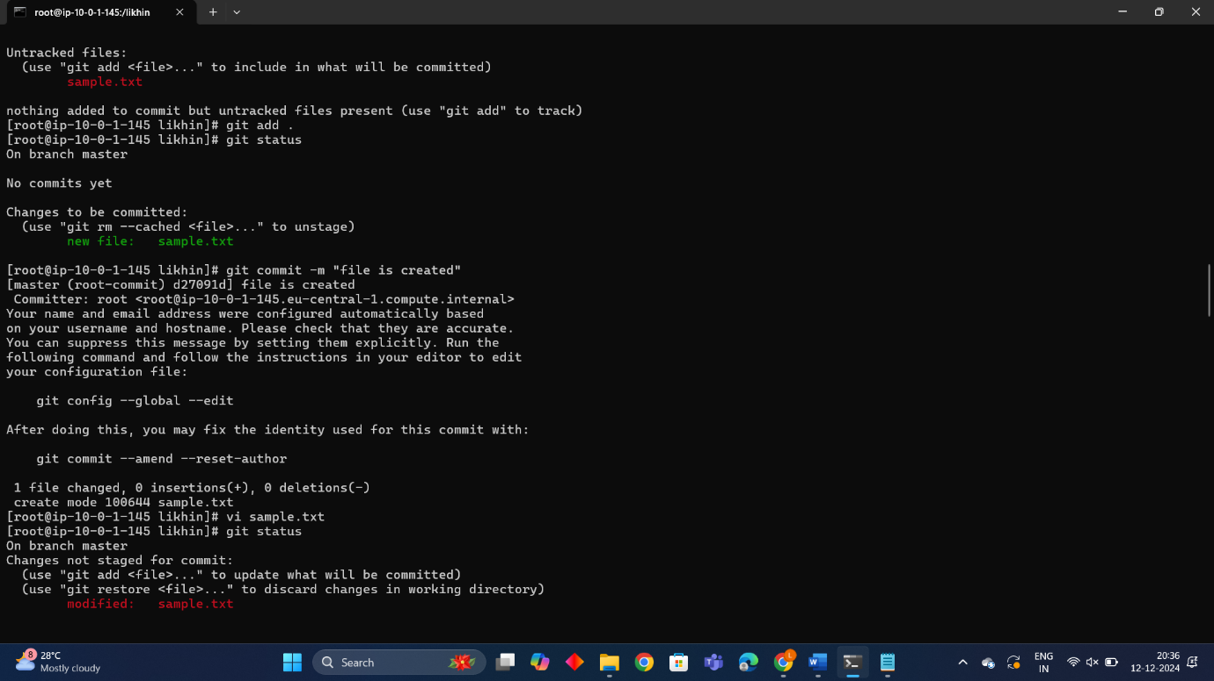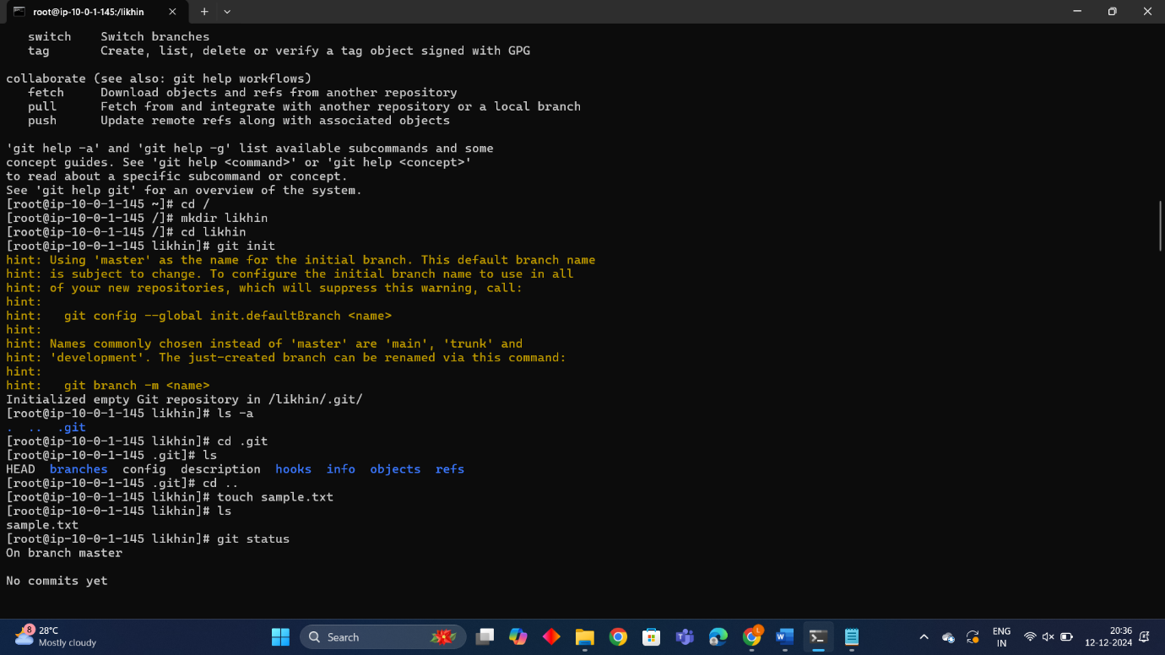

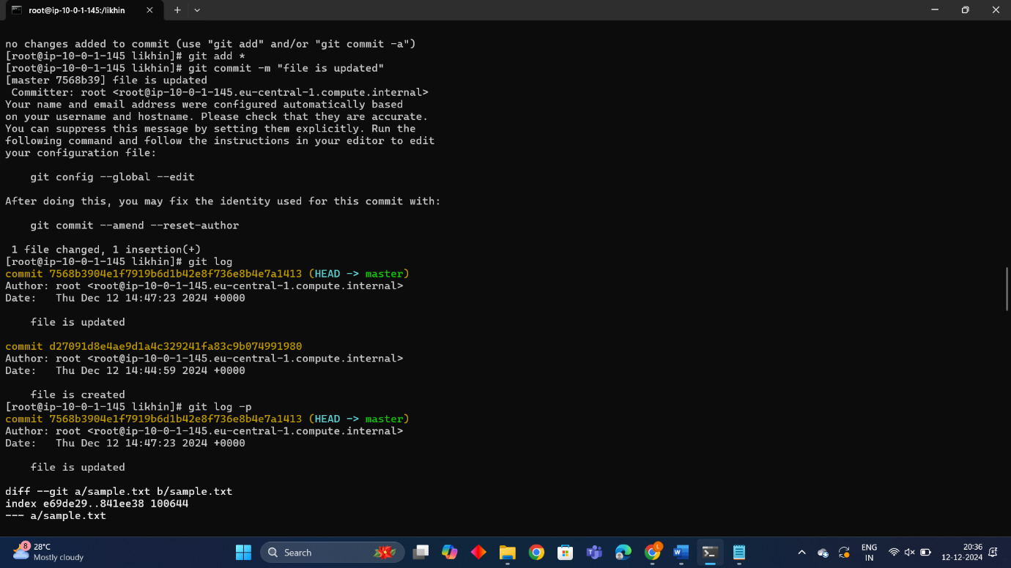

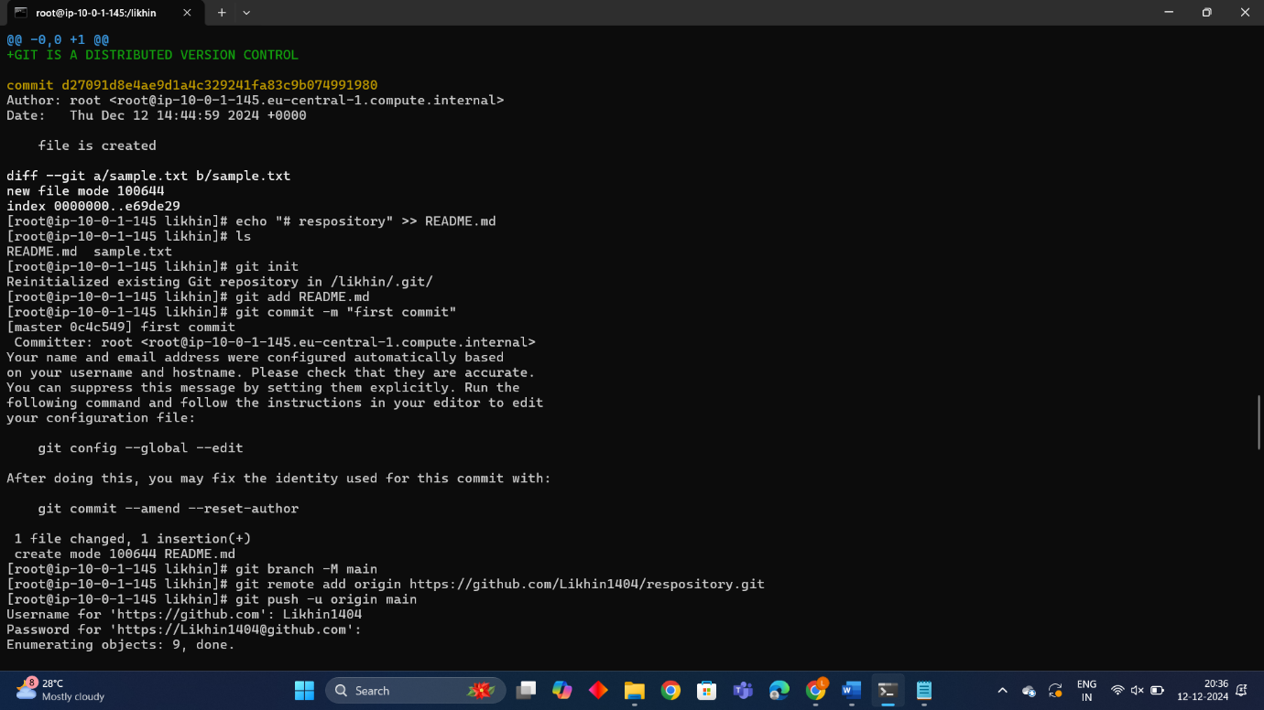

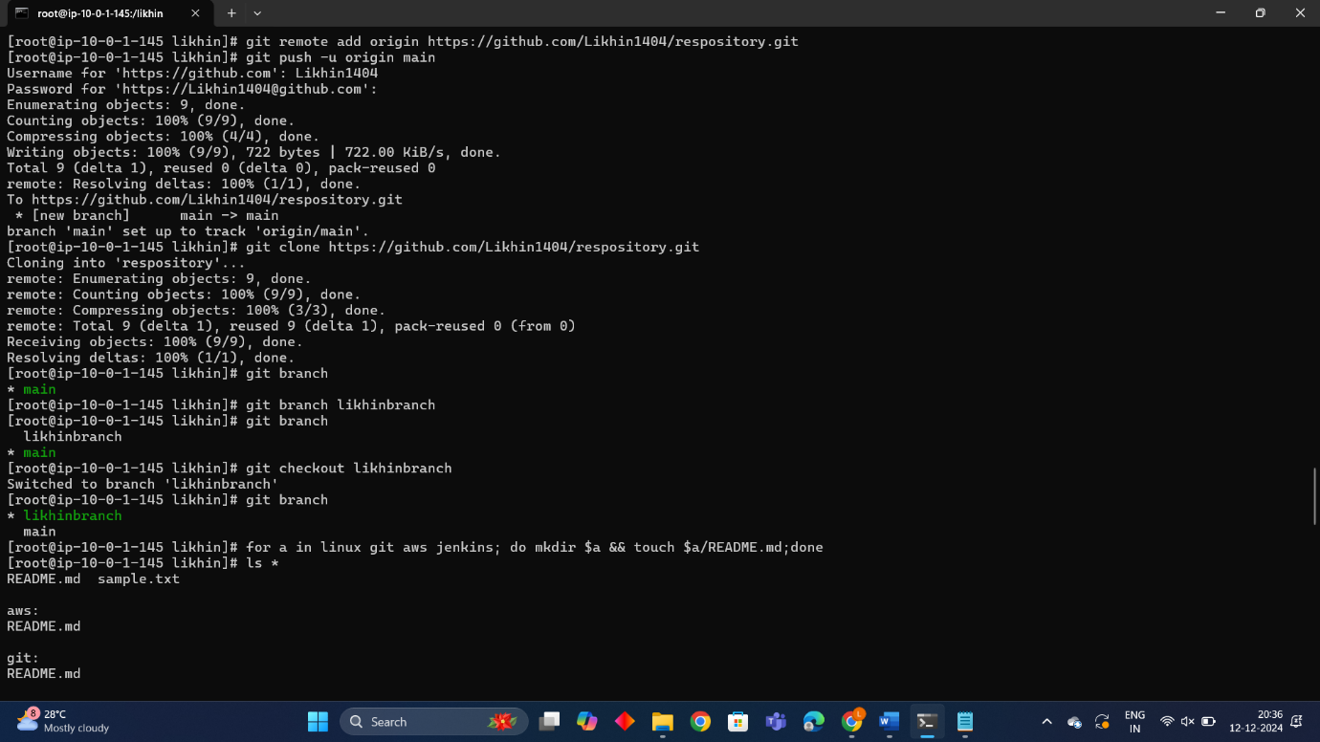

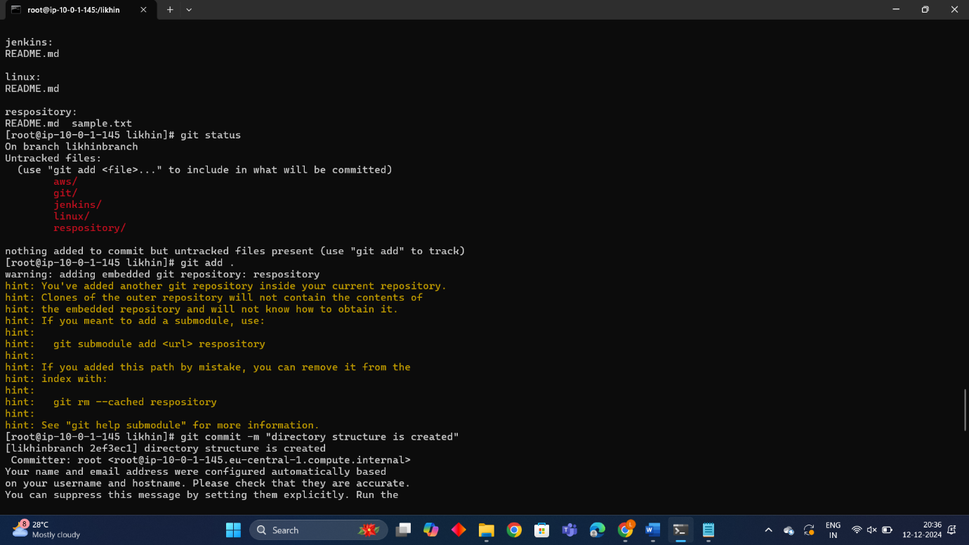

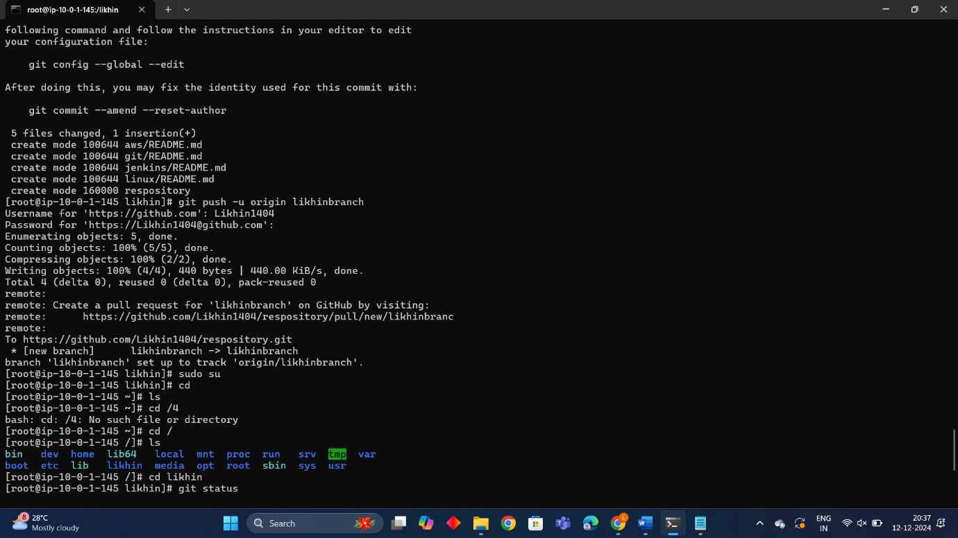

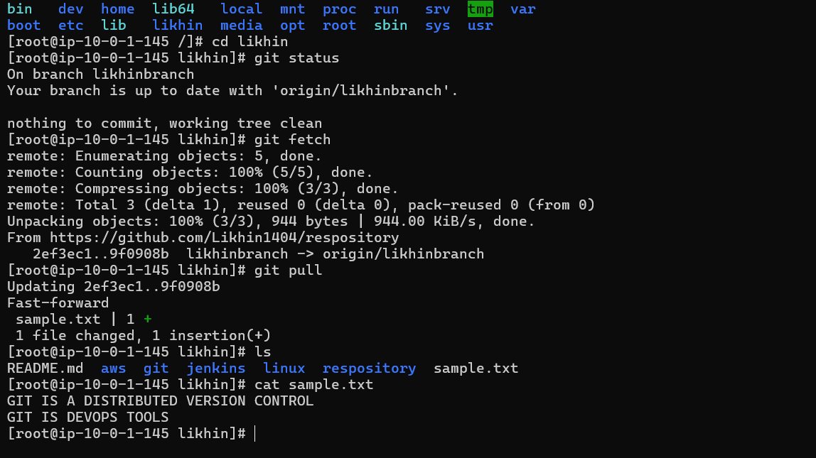

Clone git hub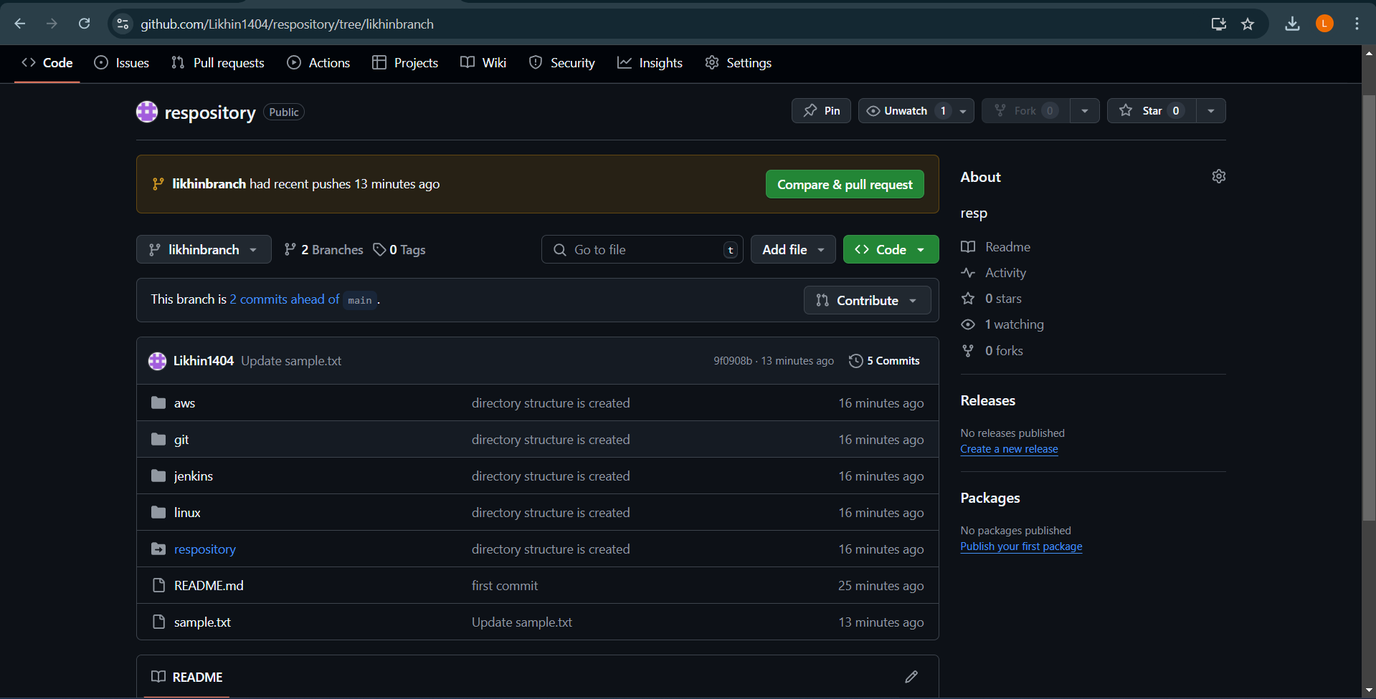

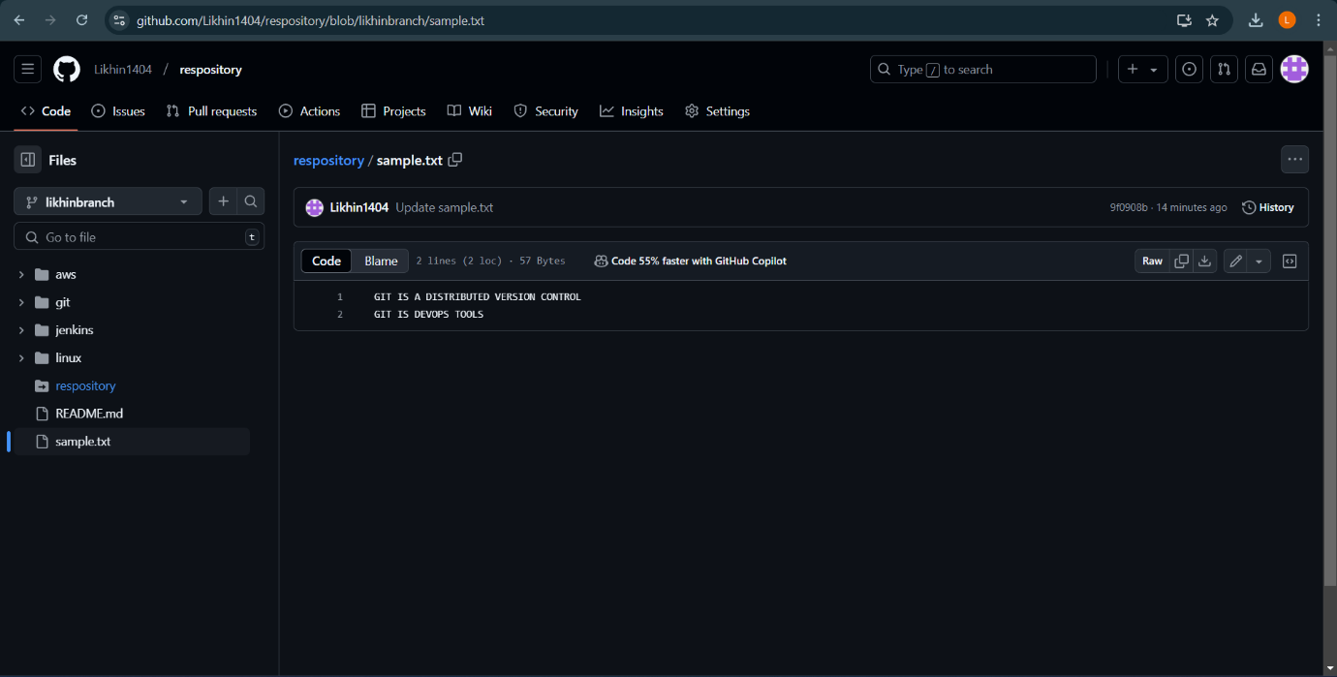

Project 7

How to download and run project from GITHUB

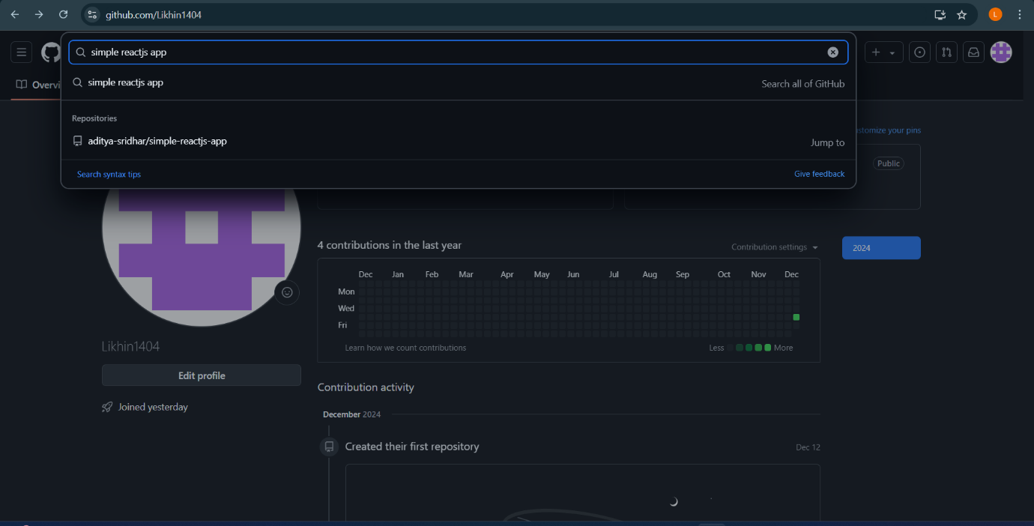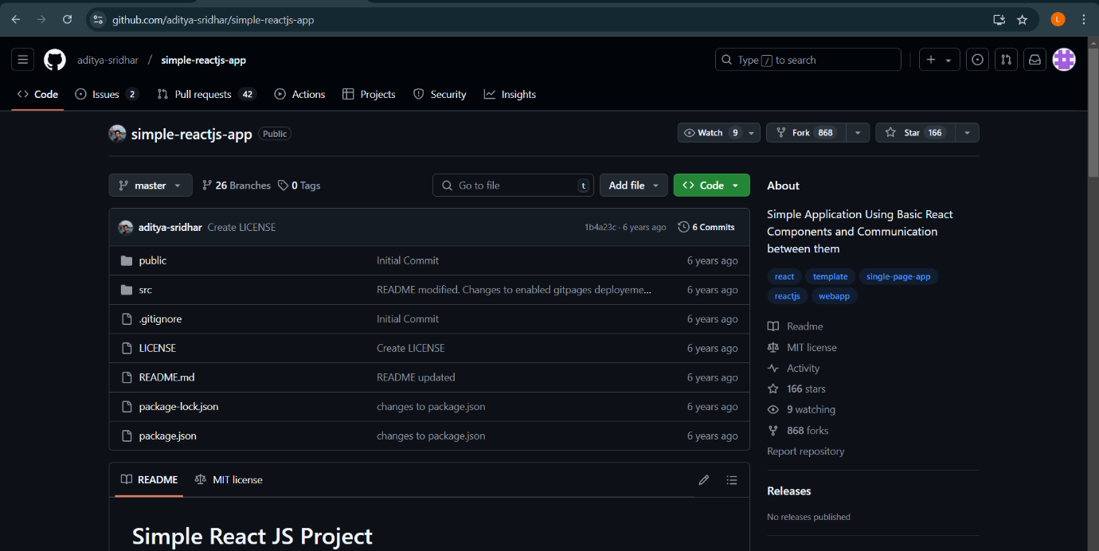

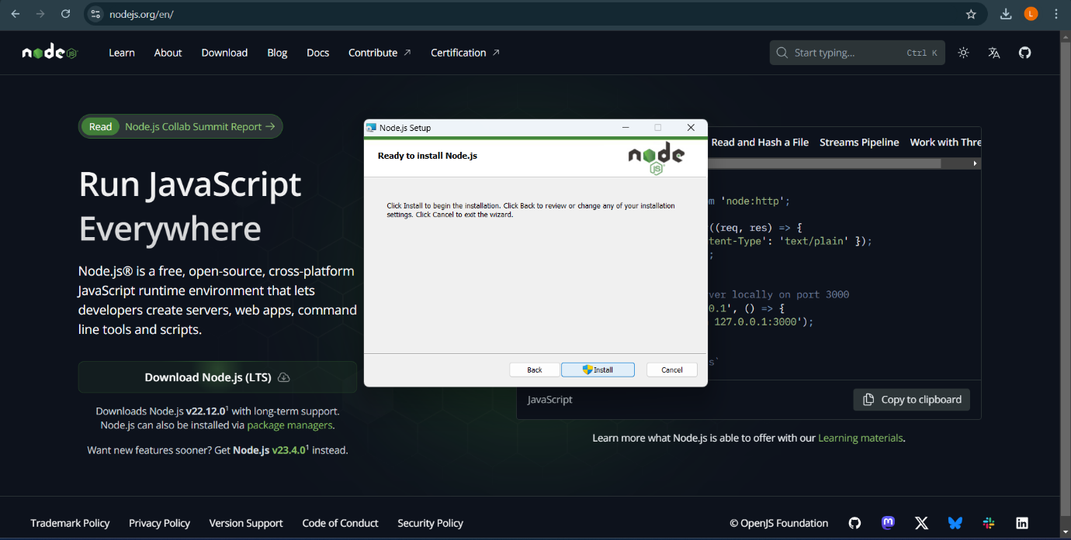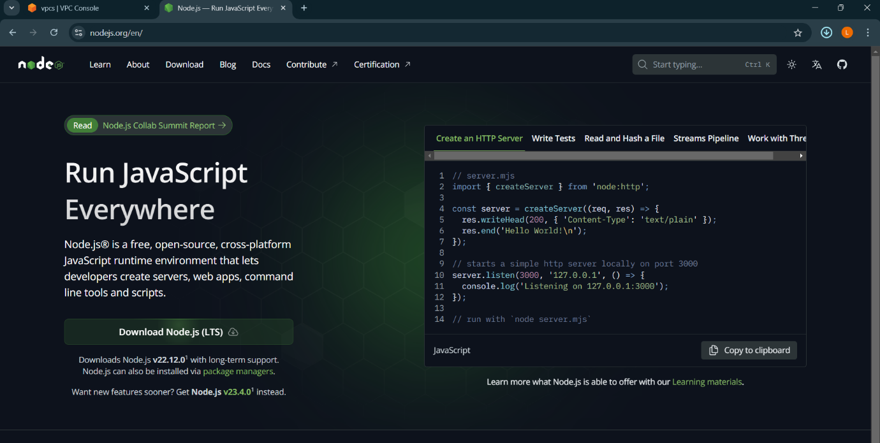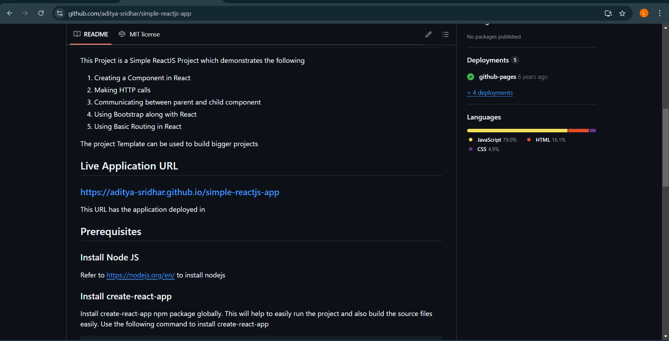

Repositories: simple-reactjs-app 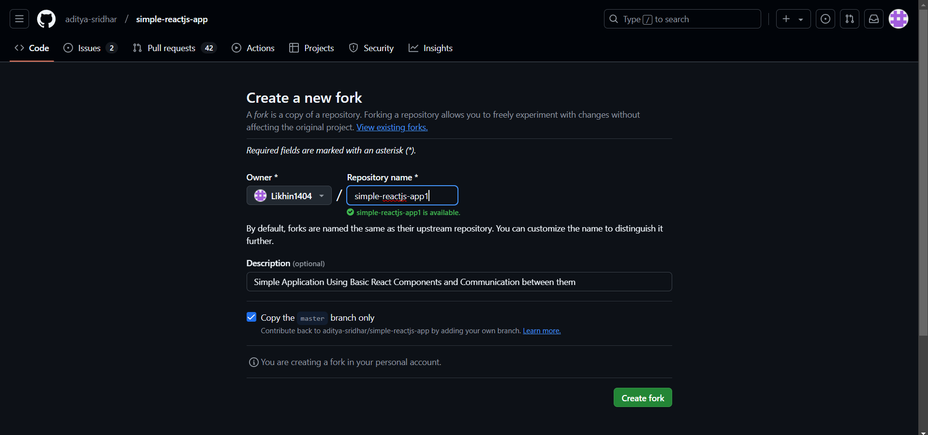

Clone url:

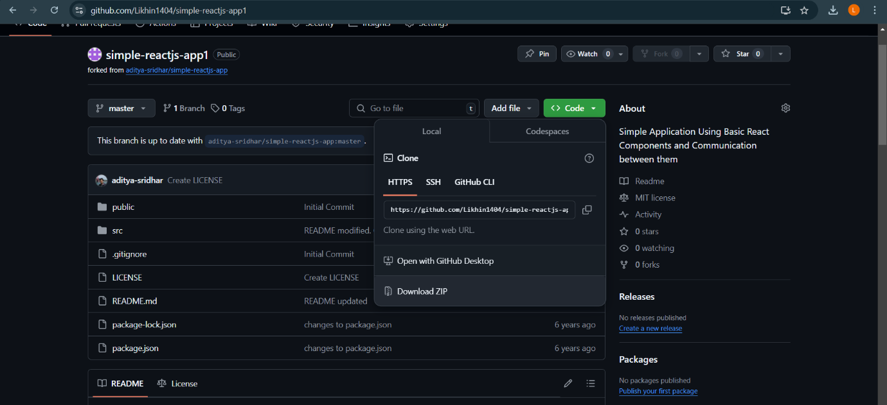

Command prompt: cloning the simple nodejs app 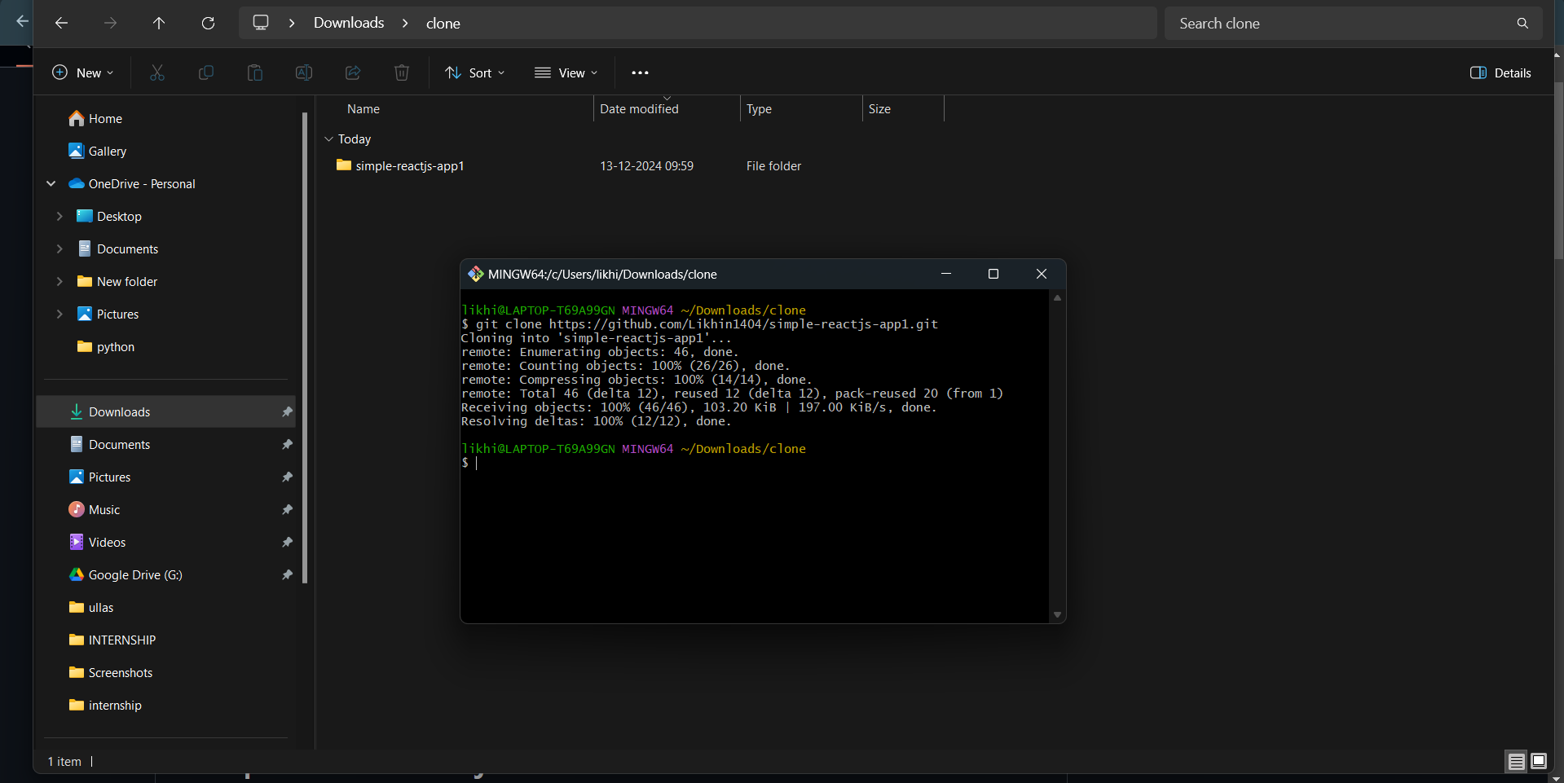

Cloned simple-reactjs-app:

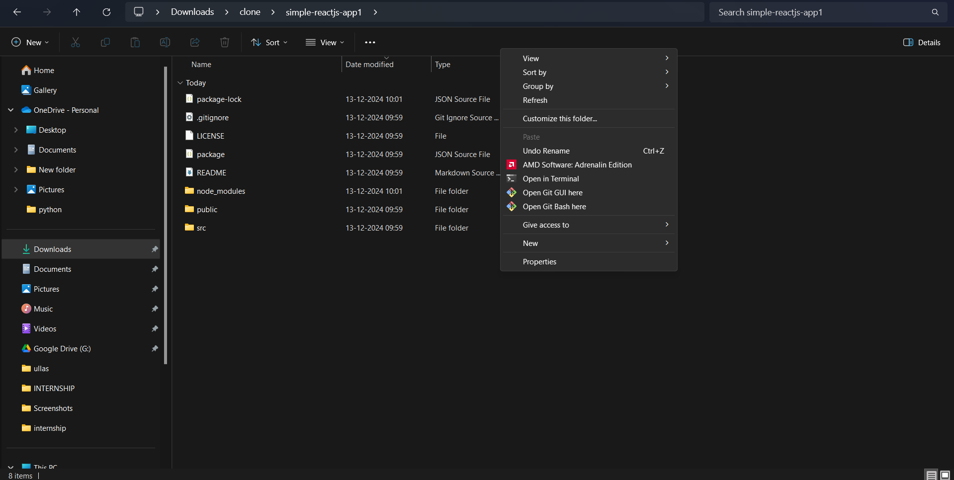

Command prompt:

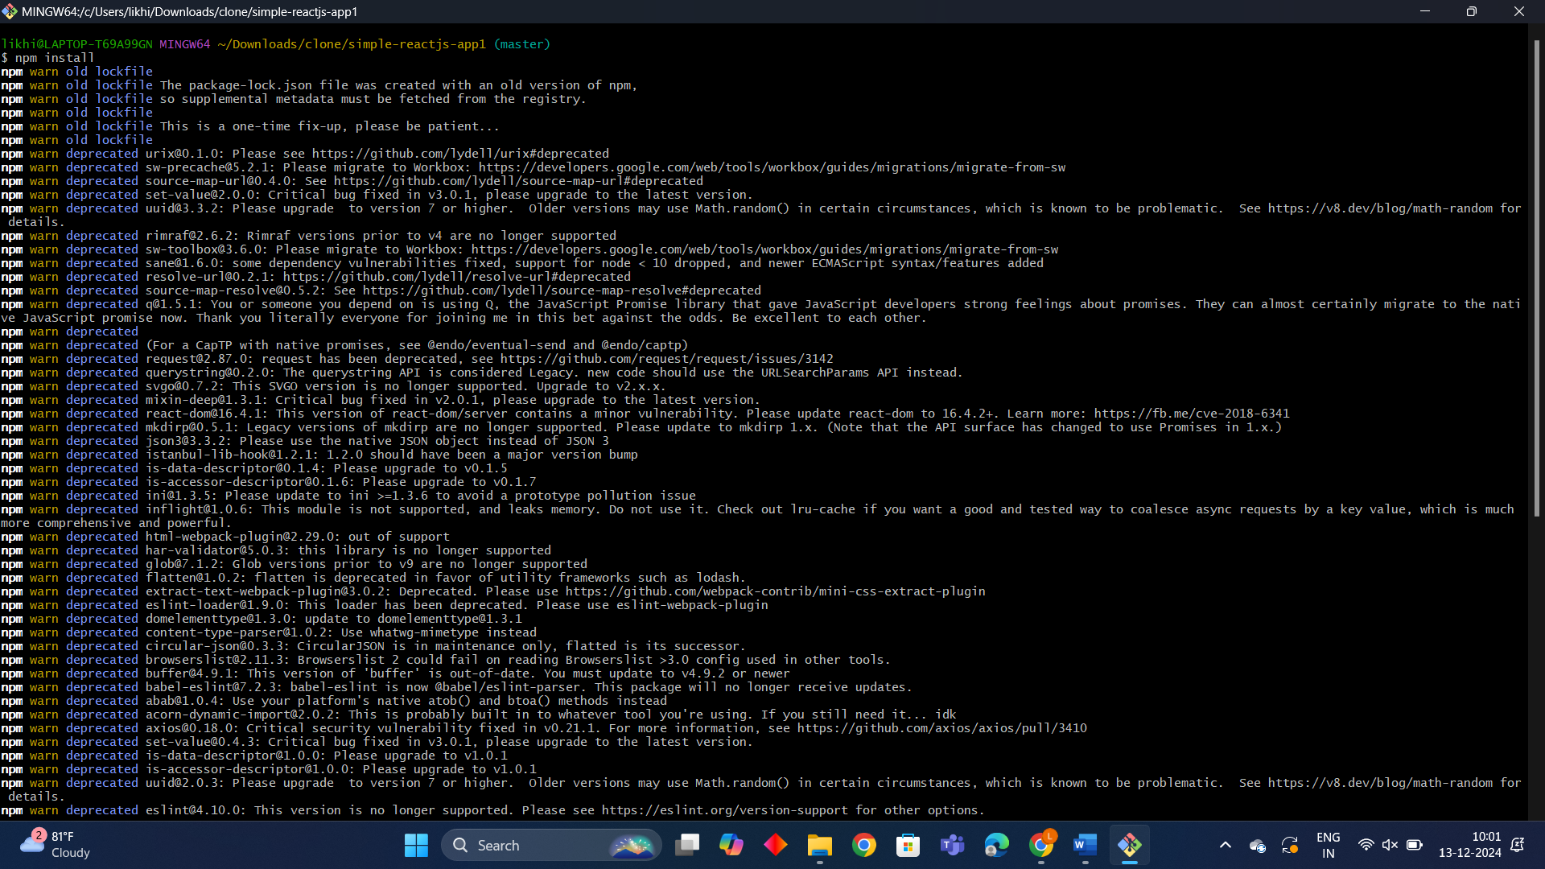  
Final result:

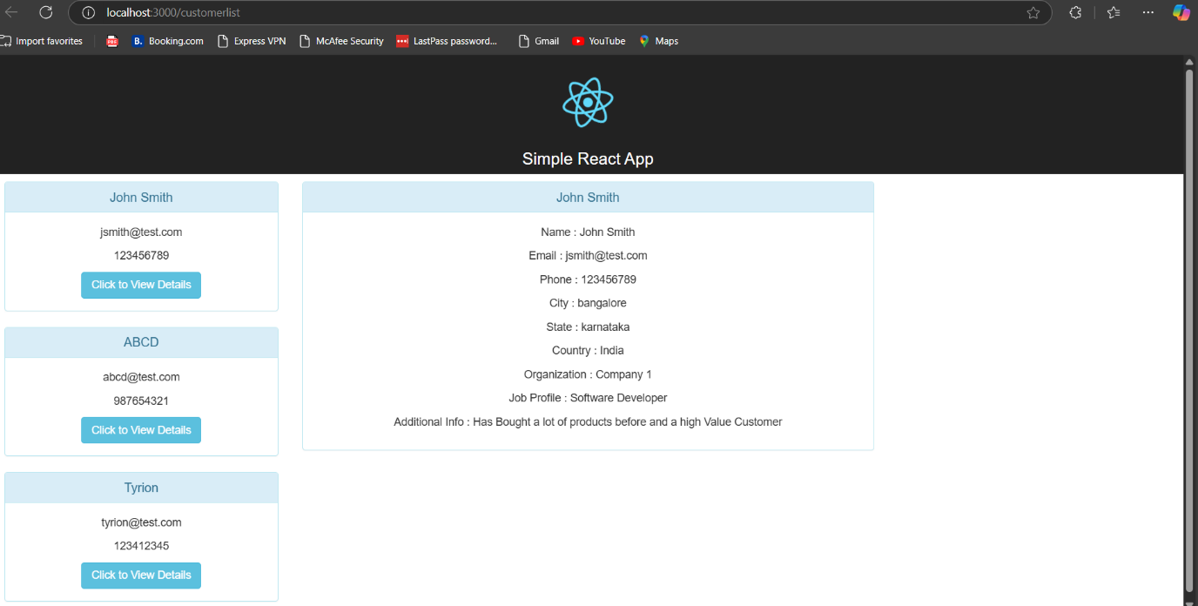

Project -8

How to clone GitHub with Jenkins using Poll SCM Build Trigger

Creating the job-3-likhin:

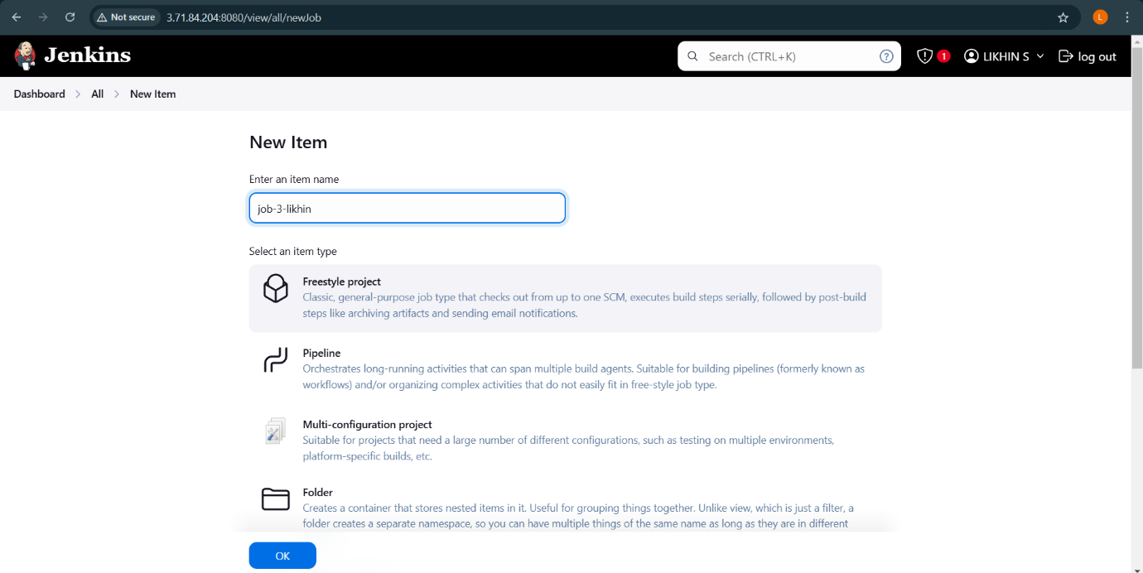

Selecting the Source code management:

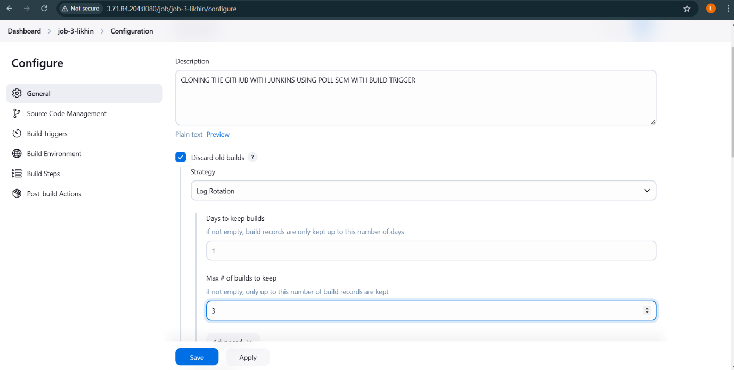

Copying the repository url:

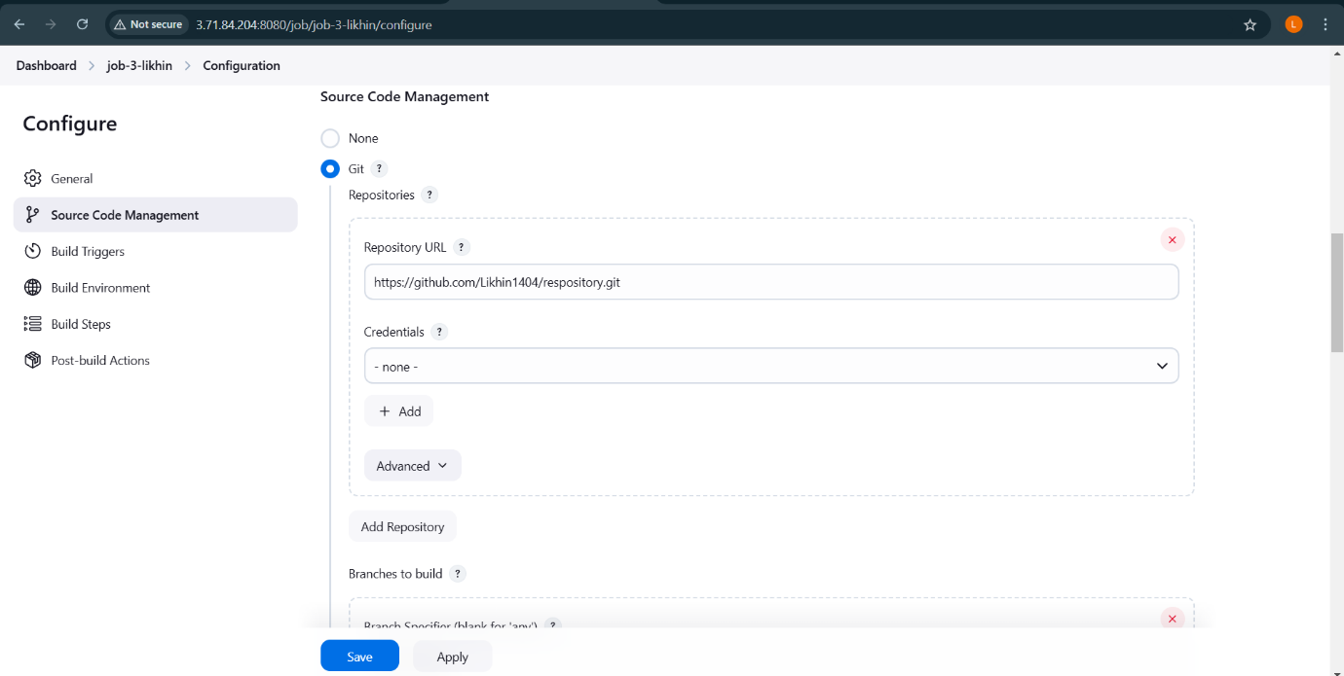

Build Trigger:

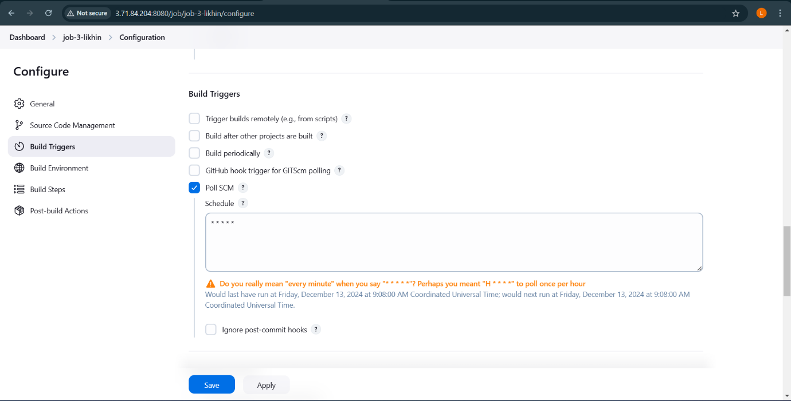

Editing the sample.txt file and committing the changes:

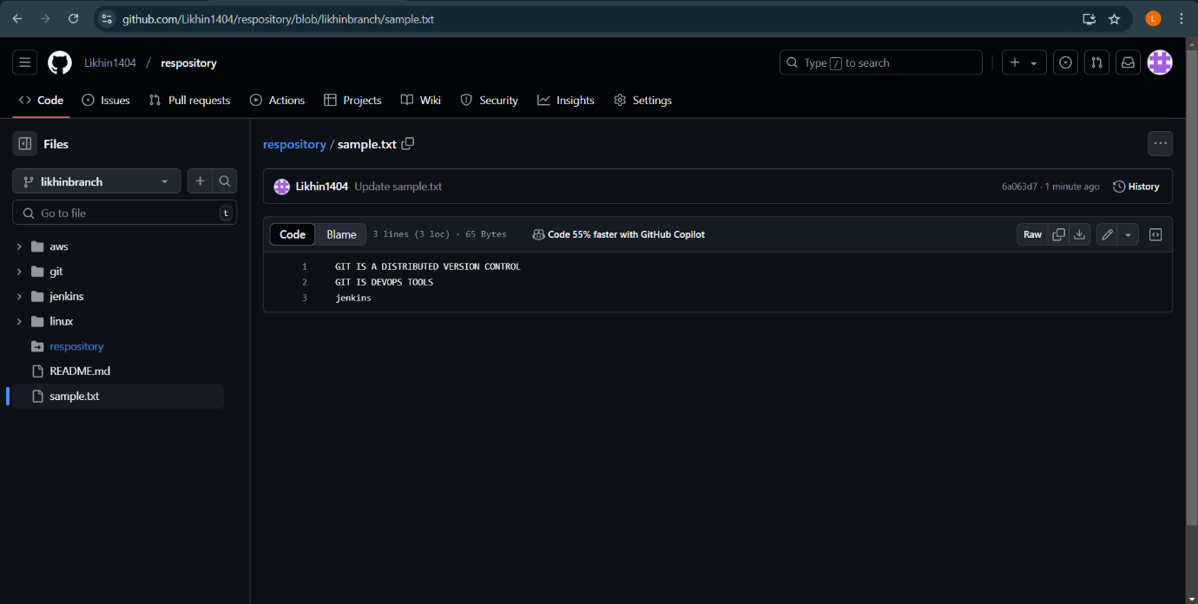

Status:

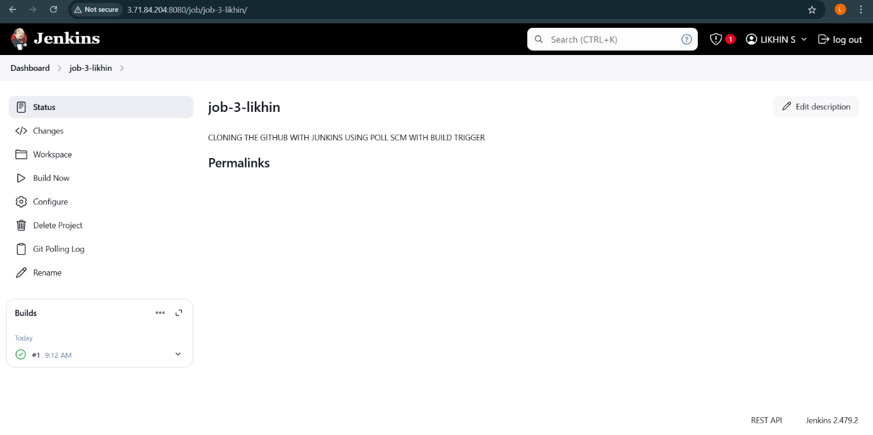

Final Result:

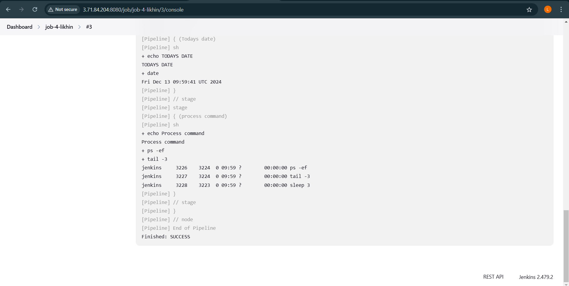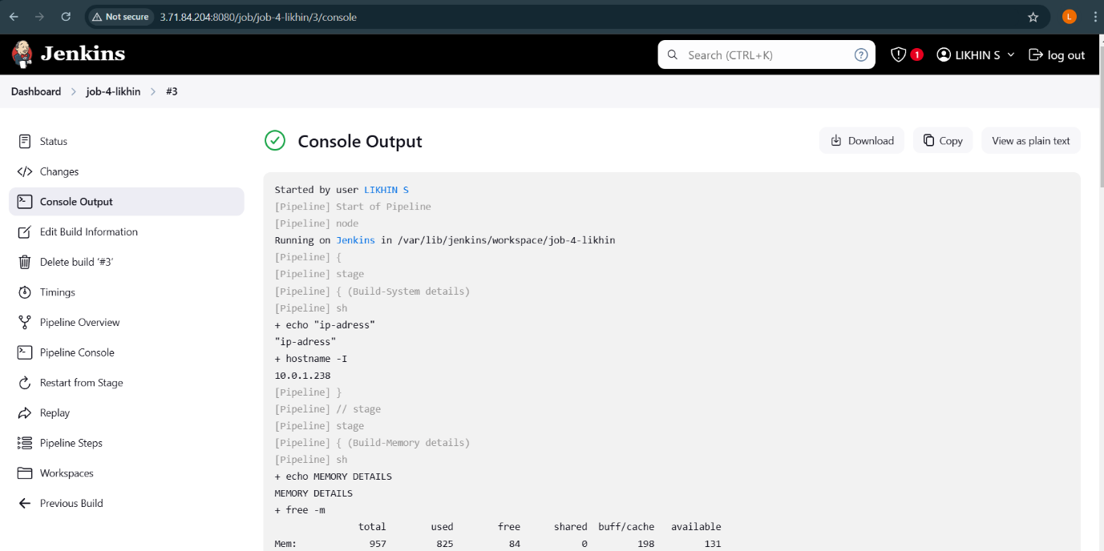

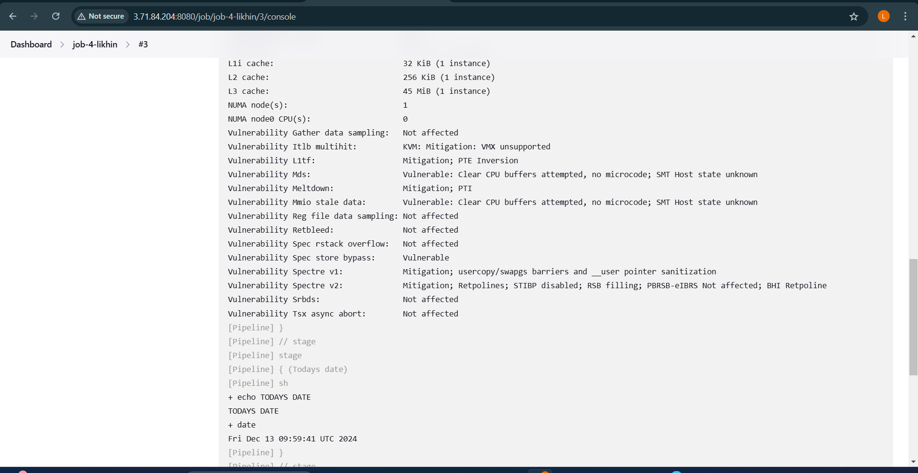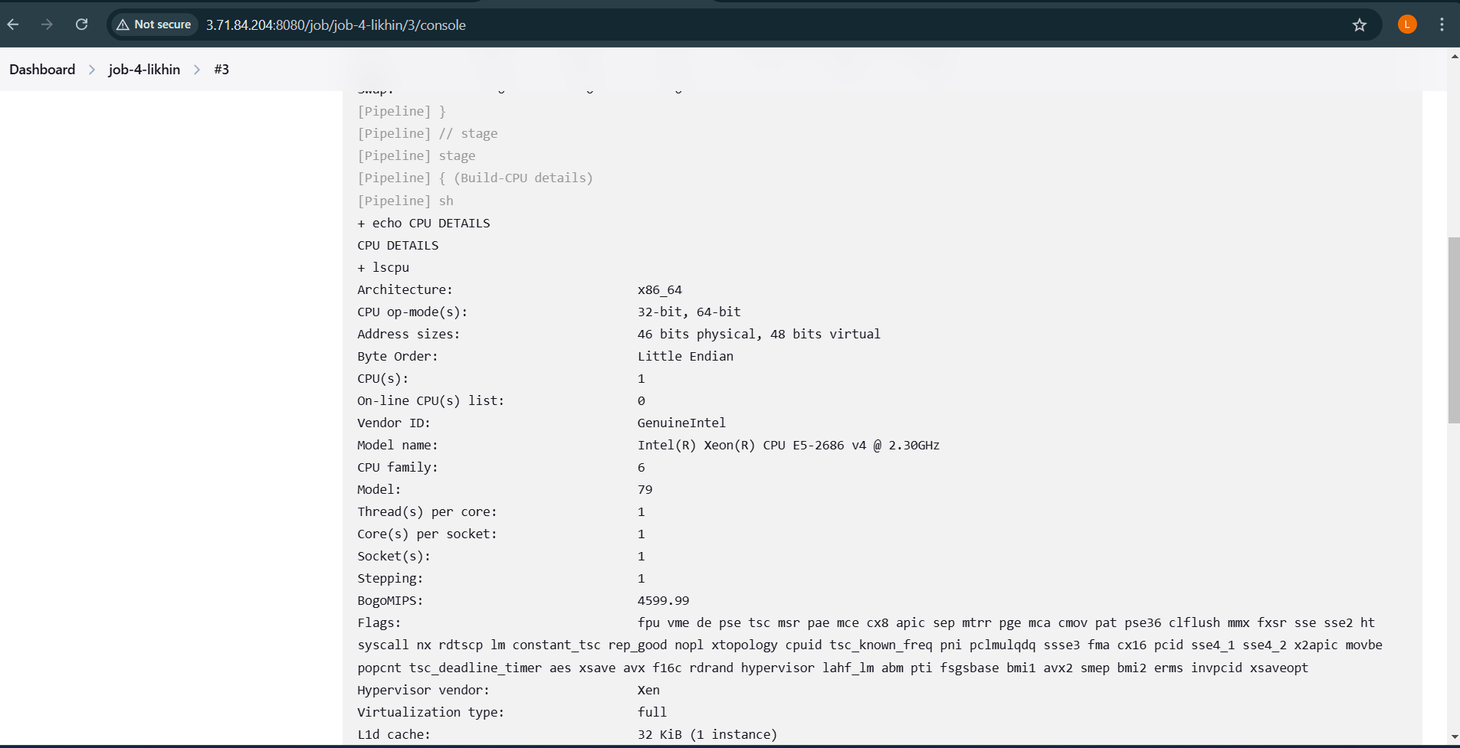

Project -9

How to automatically trigger the job in Jenkins using pipelines integrating with GitHub

Dashboard:

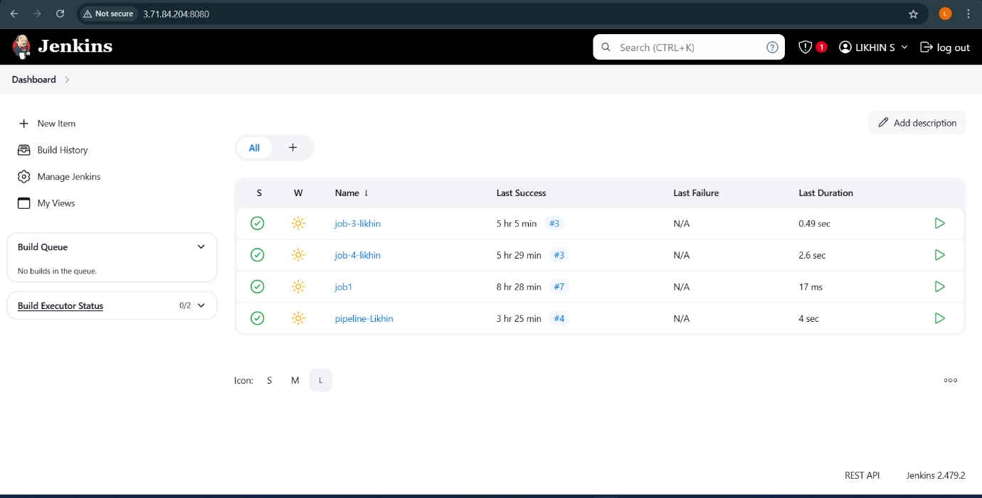

Creating Webhook:

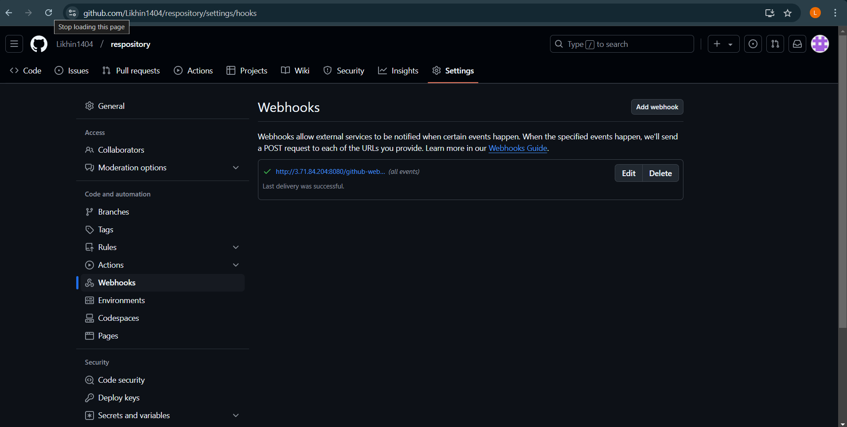

Status:

Stage logs: 